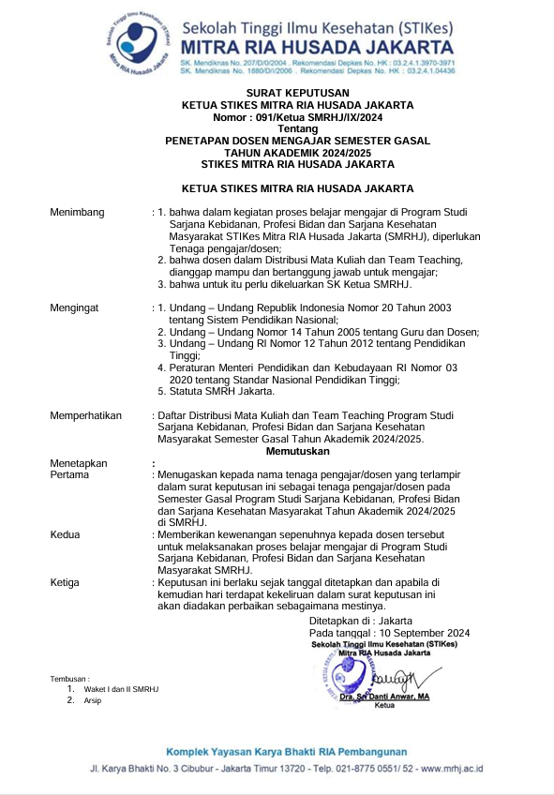

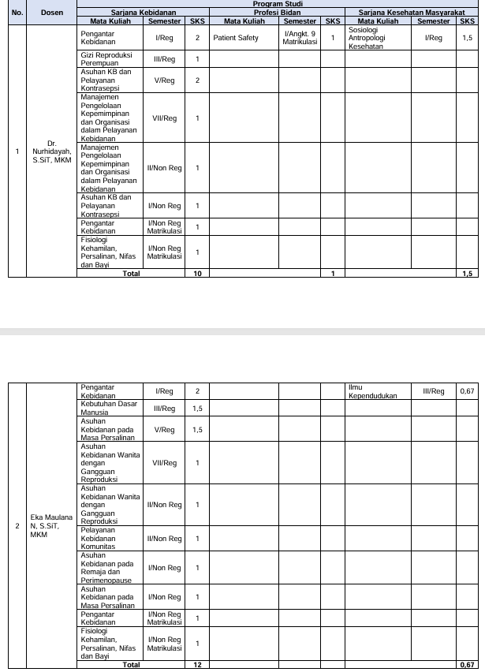

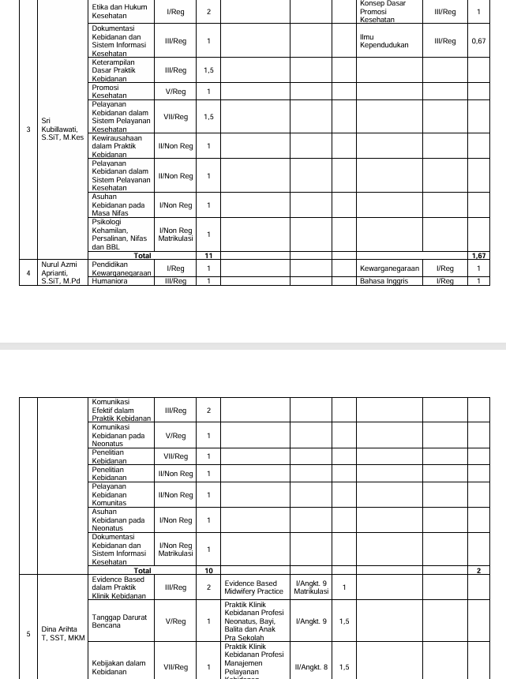

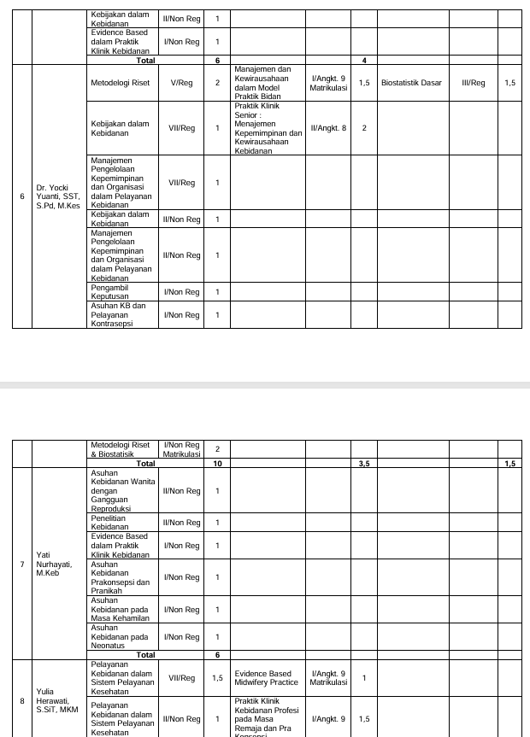

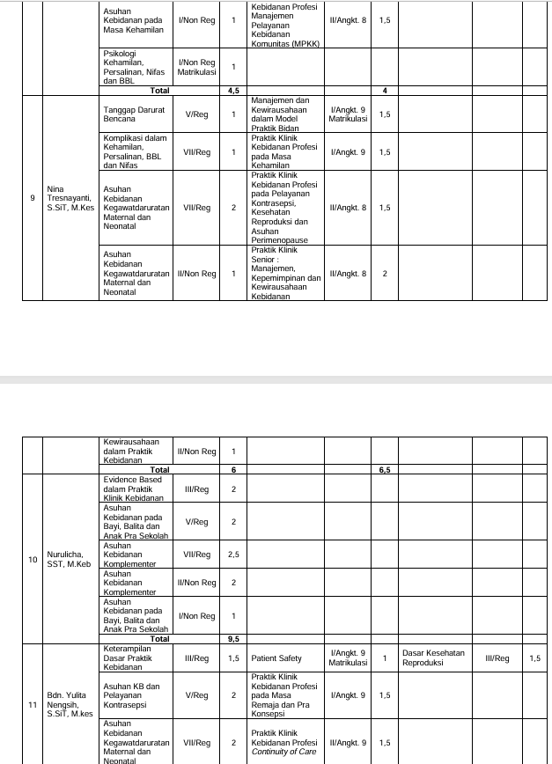

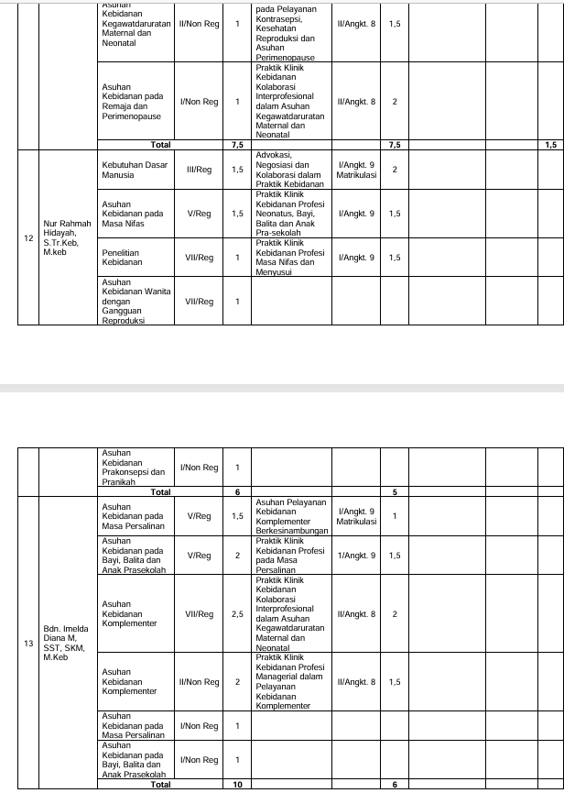

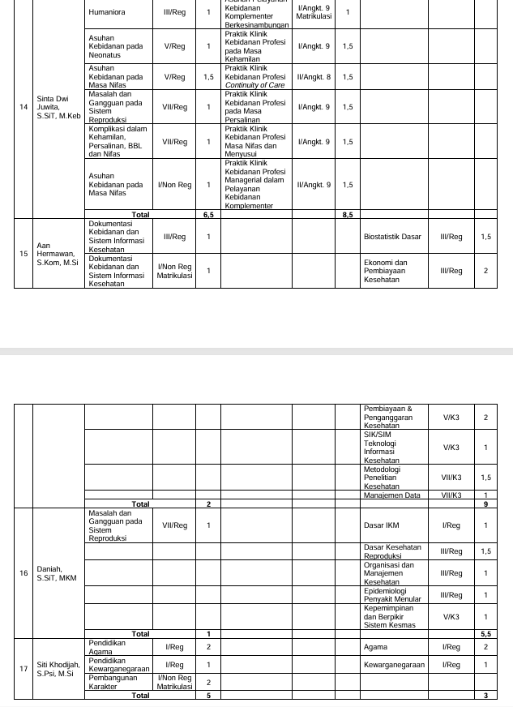

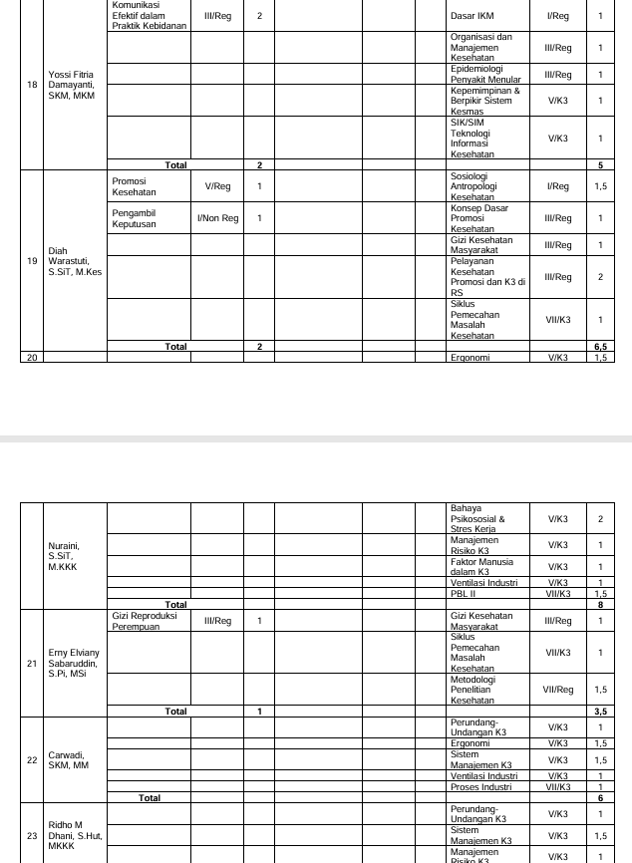

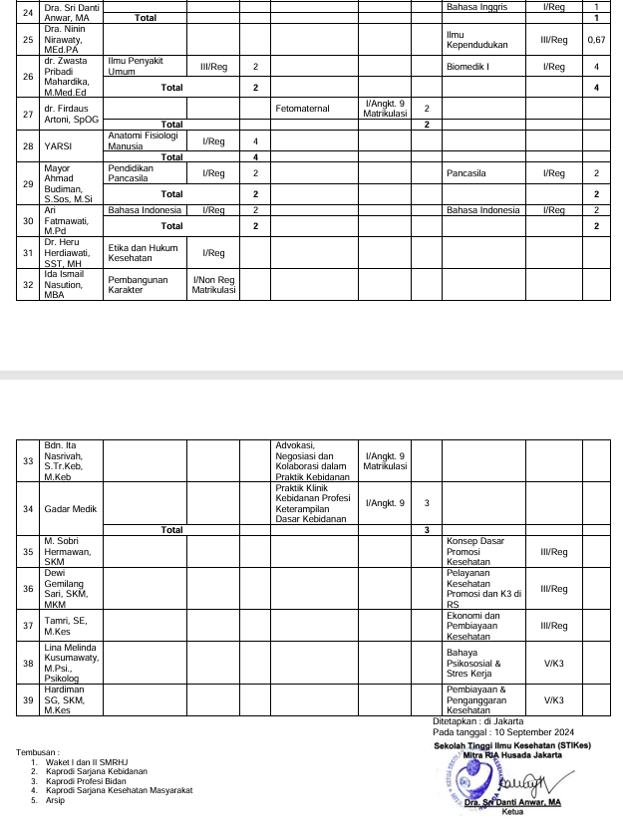

|  |  |
| --- | --- |
|  |  |

**LAPORAN PERSENTASE PRESENSI MAHASISWA  
S1 - KEBIDANAN  
20241**

|  |  |  |  |  |  |
| --- | --- | --- | --- | --- | --- |
| Mata kuliah | : | ASUHAN KEBIDANAN PADA NEONATUS | Nama Kelas | : | 1 A |
| Dosen Pengajar | : | YATI NURHAYATI |  |  |  |

|  |  |  |  |  |  |  |  |  |
| --- | --- | --- | --- | --- | --- | --- | --- | --- |
| **No** | **NIM** | **Nama** | **Pertemuan** | **Alfa** | **Hadir** | **Ijin** | **Sakit** | **Presentase** |
| Peserta Reguler | | | | | | | | |
| 1 | 24505001 | RISA YULIYANTI | 16 |  | 16 |  |  | 100 |
| 2 | 24505002 | MUNAWATI | 16 |  | 16 |  |  | 100 |
| 3 | 24505007 | DEWI SIPA MENTARI | 16 |  | 16 |  |  | 100 |
| 4 | 24505008 | NENG NUROHIMAH | 16 |  | 16 |  |  | 100 |
| 5 | 24505009 | KHAEVA ABDALELA | 16 |  | 16 |  |  | 100 |
| 6 | 24505012 | DESI MULYANI | 16 |  | 16 |  |  | 100 |
| 7 | 24505013 | HERLIYANI | 16 |  | 16 |  |  | 100 |
| 8 | 24505014 | DEWI PURNAMA | 16 |  | 16 |  |  | 100 |
| 9 | 24505015 | SITI FAUZIAH | 16 |  | 16 |  |  | 100 |
| 10 | 24505016 | IIS RISDIYANTI | 16 |  | 16 |  |  | 100 |
| 11 | 24505017 | HENI AWALIYAH | 16 |  | 16 |  |  | 100 |
| 12 | 24505018 | LELIS NURLAELI | 16 |  | 16 |  |  | 100 |
| 13 | 24505019 | YUYU YUNIARTI | 16 |  | 16 |  |  | 100 |
| 14 | 24505020 | FIRNA RIZNI PARAMITHA | 16 |  | 16 |  |  | 100 |
| 15 | 24505021 | DESI AMALIA PANDINI | 16 |  | 16 |  |  | 100 |
| 16 | 24505022 | YETI SETIAWATI | 16 |  | 16 |  |  | 100 |
| 17 | 24505023 | DESI LUIS ALPIONITA | 16 |  | 16 |  |  | 100 |
| 18 | 24505024 | CUCU ROSITA | 16 |  | 16 |  |  | 100 |
| 19 | 24505025 | IRMA NURPATIHAH | 16 |  | 16 |  |  | 100 |
| 20 | 24505026 | NOVI LUSIANDI | 16 |  | 16 |  |  | 100 |
| 21 | 24505027 | ROHESIH | 16 |  | 16 |  |  | 100 |
| 22 | 24505029 | EVA KOMALASARI | 16 |  | 16 |  |  | 100 |
| 23 | 24505031 | EVA LESTARI | 16 |  | 16 |  |  | 100 |
| 24 | 24505032 | NENGSIH MIYATI | 16 |  | 16 |  |  | 100 |
| 25 | 24505034 | RATU RESTI CAHYANI | 16 |  | 16 |  |  | 100 |
| 26 | 24505037 | DEDE ELIA FEBRIANI | 16 |  | 16 |  |  | 100 |
| 27 | 24505038 | RIFA AULIA | 16 |  | 16 |  |  | 100 |
| 28 | 24505043 | ERFA HERLINSYAH | 16 |  | 16 |  |  | 100 |
| 29 | 24505044 | IRMA NIRMALA | 16 |  | 16 |  |  | 100 |
| 30 | 24505055 | YULI APRIANTI | 16 |  | 16 |  |  | 100 |
| 31 | 24505056 | RITA ROSDIANA | 16 |  | 16 |  |  | 100 |
| 32 | 24505058 | TITIN PUSPITASARI | 16 |  | 16 |  |  | 100 |
| 33 | 24505060 | NISA MULYAWATI | 16 |  | 16 |  |  | 100 |
| 34 | 24505061 | ILMA NOOR AJIZAH | 16 |  | 16 |  |  | 100 |
| 35 | 24505065 | DITA DWI TAFRINA | 16 |  | 16 |  |  | 100 |
| 36 | 24505073 | NINING KARLINA | 16 |  | 15 |  |  | 93.75 |
| 37 | 24505076 | AI IMAS JAMILLAH | 16 |  | 16 |  |  | 100 |

Jakarta, 16 Januari 2025  
Ketua Prodi S1 - Kebidanan  
  
Dr. NURHIDAYAH, S.SiT, MKM  
NIP. 0323057501



**LAPORAN PERSENTASE PRESENSI MAHASISWA  
S1 - KEBIDANAN  
20241**

|  |  |  |  |  |  |
| --- | --- | --- | --- | --- | --- |
| Mata kuliah | : | ASUHAN KEBIDANAN PADA NEONATUS | Nama Kelas | : | 1 B |
| Dosen Pengajar | : | YATI NURHAYATI |  |  |  |

|  |  |  |  |  |  |  |  |  |
| --- | --- | --- | --- | --- | --- | --- | --- | --- |
| **No** | **NIM** | **Nama** | **Pertemuan** | **Alfa** | **Hadir** | **Ijin** | **Sakit** | **Presentase** |
| Peserta Reguler | | | | | | | | |
| 1 | 23504059 | EMI TINEKE PETRONELA TAIME | 16 | 2 | 12 |  | 2 | 75 |
| 2 | 24505003 | FAZRIAH NABILAH AL FAUZIAH SYAHDA | 16 |  | 16 |  |  | 100 |
| 3 | 24505004 | MANAL | 16 |  | 16 |  |  | 100 |
| 4 | 24505005 | MEILAWATI PUTRI PRATIWI | 16 |  | 16 |  |  | 100 |
| 5 | 24505006 | CAHAYA LINTANG PRIMA DIGDAYA | 16 |  | 16 |  |  | 100 |
| 6 | 24505010 | YUHANIPA | 16 |  | 16 |  |  | 100 |
| 7 | 24505011 | SHINTIYA LOREN | 16 |  | 16 |  |  | 100 |
| 8 | 24505028 | DEBY ANISSA | 16 |  | 16 |  |  | 100 |
| 9 | 24505030 | SILPI NOPIANTI | 16 |  | 16 |  |  | 100 |
| 10 | 24505033 | SITI HANA VITA | 16 |  | 16 |  |  | 100 |
| 11 | 24505035 | REGINA MULYASARI | 16 |  | 16 |  |  | 100 |
| 12 | 24505036 | UUM UMBARAWATI LARA DEWI | 16 |  | 16 |  |  | 100 |
| 13 | 24505039 | AYU SIMAREMARE | 16 |  | 16 |  |  | 100 |
| 14 | 24505040 | NABIILAH NA'FA LABI'BAH | 16 |  | 16 |  |  | 100 |
| 15 | 24505041 | AYU SRI WAHYUNI | 16 |  | 16 |  |  | 100 |
| 16 | 24505042 | NINA ROSMAWATI | 16 |  | 16 |  |  | 100 |
| 17 | 24505045 | RENISA BUNGA NATASYA | 16 |  | 16 |  |  | 100 |
| 18 | 24505046 | MERRY GUSTIANA SAID | 16 |  | 16 |  |  | 100 |
| 19 | 24505047 | SITI ELISA | 16 |  | 16 |  |  | 100 |
| 20 | 24505048 | RISKA RISMAYANTI RIDWAN | 16 |  | 16 |  |  | 100 |
| 21 | 24505049 | DINDA MUTI ANGGELA | 16 |  | 16 |  |  | 100 |
| 22 | 24505050 | DIAN NURMASARI | 16 |  | 16 |  |  | 100 |
| 23 | 24505051 | MAGHFIRAH | 16 |  | 16 |  |  | 100 |
| 24 | 24505052 | YULI INDRA SETIYO LESTARI | 16 |  | 16 |  |  | 100 |
| 25 | 24505053 | VELLA EFIANA | 16 |  | 16 |  |  | 100 |
| 26 | 24505054 | NURYANTI | 16 |  | 16 |  |  | 100 |
| 27 | 24505057 | AYU ASTIKA PARWI | 16 |  | 16 |  |  | 100 |
| 28 | 24505059 | DIAN NURLELA | 16 |  | 16 |  |  | 100 |
| 29 | 24505062 | SUSI AYUNINGSIH | 16 |  | 16 |  |  | 100 |
| 30 | 24505063 | NEUIS MALIHAH | 16 |  | 16 |  |  | 100 |
| 31 | 24505064 | JULLY LATUHIHIN | 16 |  | 16 |  |  | 100 |
| 32 | 24505066 | PUTRI LATIFAH | 16 |  | 16 |  |  | 100 |
| 33 | 24505067 | DINI HANDAYANI | 16 |  | 16 |  |  | 100 |
| 34 | 24505068 | AMIRA RAFIKA SARI | 16 |  | 16 |  |  | 100 |
| 35 | 24505069 | AGISNI SARI | 16 |  | 16 |  |  | 100 |
| 36 | 24505070 | SAMSUDDUHA CIRIMAI PUTRI | 16 |  | 16 |  |  | 100 |
| 37 | 24505071 | AI SRI WIDIAWATI | 16 |  | 16 |  |  | 100 |
| 38 | 24505072 | BUNGA SALIA RAHMAWATI | 16 |  | 16 |  |  | 100 |
| 39 | 24505075 | RIBKA JUNITA YOKU | 16 | 2 | 12 |  | 2 | 75 |
| 40 | 24505077 | DEA AYU FRASTICA | 16 |  | 16 |  |  | 100 |
| 41 | 24505078 | DORCI YEUW | 16 | 1 | 14 |  | 1 | 87.5 |

Jakarta, 16 Januari 2025  
Ketua Prodi S1 - Kebidanan  
  
Dr. NURHIDAYAH, S.SiT, MKM  
NIP. 0323057501



**ISI PRESENSI DOSEN S1 – KEBIDANAN 20232**

|  |  |  |  |  |  |
| --- | --- | --- | --- | --- | --- |
| Mata kuliah | : | BD63083 - ASUHAN KEBIDANAN PADA NEONATUS | Nama Kelas | : | 1 A |

|  |  |  |  |  |  |  |  |  |  |  |  |  |  |  |  |  |  |  |
| --- | --- | --- | --- | --- | --- | --- | --- | --- | --- | --- | --- | --- | --- | --- | --- | --- | --- | --- |
| **No** | **NIP** | **NAMA** | **TATAP MUKA** | | | | | | | | | | | | | | | |
| **20 Sep 2024** | **27 Sep 2024** | **4 Okt 2024** | **11 Okt 2024** | **18 Okt 2024** | **25 Okt 2024** | **1 Nov 2024** | **7 Nov 2024** | **13 Nov 2024** | **20 Nov 2024** | **27 Nov 2024** | **4 Des 2024** | **11 Des 2024** | **18 Des 2024** | **23 Des 2024** | **9 Jan 2025** |
| 1 | 190223466 | Yati Nurhayati, S.ST., M.Keb |  |  |  |  |  |  |  |  | - | - | - | - | - | - | - | - |
| 2 | 154216355 | Nurul Azmi Aprianti, S.ST., M.Pd | - | - | - | - | - | - | - | - |  |  |  |  |  |  |  |  |

|  |  |
| --- | --- |
|  |  |

**NILAI PERKULIAHAN MAHASISWA**

|  |  |  |
| --- | --- | --- |
| **PRODI** | **:** | **S1 - KEBIDANAN** |
| **PERIODE** | **:** | **20241** |

|  |  |  |  |  |  |
| --- | --- | --- | --- | --- | --- |
| Mata kuliah | : | ASUHAN KEBIDANAN PADA NEONATUS | Nama Kelas | : | 1 A |
| Kode Mata kuliah | : | BD63083 | SKS | : | 2 |

|  |  |  |  |  |  |  |  |  |  |  |
| --- | --- | --- | --- | --- | --- | --- | --- | --- | --- | --- |
| **No** | **NIM** | **Nama Mahasiswa** | **TUGAS INDIVIDU (25%)** | **QUIZ (10%)** | **PARTISIPAN (10%)** | **UTS (25%)** | **UAS (30%)** | **Nilai** | **Grade** | **Lulus** |
| 1 | 24505001 | RISA YULIYANTI | 76.00 | 70.00 | 90.00 | 71.50 | 61.00 | 71.18 | B | ✔ |
| 2 | 24505002 | MUNAWATI | 76.00 | 73.00 | 90.00 | 65.00 | 71.00 | 72.85 | B | ✔ |
| 3 | 24505007 | DEWI SIPA MENTARI | 85.00 | 89.00 | 90.00 | 82.50 | 93.00 | 87.68 | A | ✔ |
| 4 | 24505008 | NENG NUROHIMAH | 85.00 | 88.00 | 90.00 | 85.00 | 91.00 | 87.60 | A | ✔ |
| 5 | 24505009 | KHAEVA ABDALELA | 85.00 | 89.00 | 90.00 | 82.50 | 93.00 | 87.68 | A | ✔ |
| 6 | 24505012 | DESI MULYANI | 85.00 | 88.00 | 90.00 | 62.50 | 91.00 | 81.98 | A- | ✔ |
| 7 | 24505013 | HERLIYANI | 82.00 | 86.00 | 90.00 | 62.50 | 91.00 | 81.03 | A- | ✔ |
| 8 | 24505014 | DEWI PURNAMA | 85.00 | 81.00 | 90.00 | 57.50 | 77.00 | 75.83 | B | ✔ |
| 9 | 24505015 | SITI FAUZIAH | 76.00 | 81.00 | 90.00 | 67.50 | 86.00 | 78.78 | B+ | ✔ |
| 10 | 24505016 | IIS RISDIYANTI | 85.00 | 90.00 | 95.00 | 62.50 | 95.00 | 83.88 | A- | ✔ |
| 11 | 24505017 | HENI AWALIYAH | 76.00 | 86.00 | 90.00 | 62.50 | 96.00 | 81.03 | A- | ✔ |
| 12 | 24505018 | LELIS NURLAELI | 85.00 | 87.00 | 90.00 | 62.50 | 90.00 | 81.58 | A- | ✔ |
| 13 | 24505019 | YUYU YUNIARTI | 76.00 | 73.00 | 90.00 | 67.50 | 70.00 | 73.18 | B | ✔ |
| 14 | 24505020 | FIRNA RIZNI PARAMITHA | 85.00 | 88.00 | 90.00 | 85.00 | 91.00 | 87.60 | A | ✔ |
| 15 | 24505021 | DESI AMALIA PANDINI | 85.00 | 89.00 | 90.00 | 82.50 | 93.00 | 87.68 | A | ✔ |
| 16 | 24505022 | YETI SETIAWATI | 85.00 | 87.00 | 90.00 | 80.00 | 90.00 | 85.95 | A- | ✔ |
| 17 | 24505023 | DESI LUIS ALPIONITA | 82.00 | 86.00 | 90.00 | 80.00 | 91.00 | 85.40 | A- | ✔ |
| 18 | 24505024 | CUCU ROSITA | 85.00 | 85.00 | 95.00 | 75.00 | 86.00 | 83.80 | A- | ✔ |
| 19 | 24505025 | IRMA NURPATIHAH | 85.00 | 87.00 | 90.00 | 77.50 | 90.00 | 85.33 | A- | ✔ |
| 20 | 24505026 | NOVI LUSIANDI | 82.00 | 86.00 | 90.00 | 77.50 | 90.00 | 84.48 | A- | ✔ |
| 21 | 24505027 | ROHESIH | 82.00 | 83.00 | 90.00 | 75.00 | 85.00 | 82.05 | A- | ✔ |
| 22 | 24505029 | EVA KOMALASARI | 82.00 | 88.00 | 90.00 | 85.00 | 95.00 | 88.05 | A | ✔ |
| 23 | 24505031 | EVA LESTARI | 76.00 | 86.00 | 98.00 | 62.50 | 96.00 | 81.83 | A- | ✔ |
| 24 | 24505032 | NENGSIH MIYATI | 76.00 | 83.00 | 90.00 | 57.50 | 91.00 | 77.98 | B+ | ✔ |
| 25 | 24505034 | RATU RESTI CAHYANI | 85.00 | 90.00 | 90.00 | 82.50 | 95.00 | 88.38 | A | ✔ |
| 26 | 24505037 | DEDE ELIA FEBRIANI | 85.00 | 88.00 | 90.00 | 85.00 | 91.00 | 87.60 | A | ✔ |
| 27 | 24505038 | RIFA AULIA | 76.00 | 61.00 | 90.00 | 74.50 | 61.00 | 71.03 | B | ✔ |
| 28 | 24505043 | ERFA HERLINSYAH | 85.00 | 88.00 | 90.00 | 85.00 | 91.00 | 87.60 | A | ✔ |
| 29 | 24505044 | IRMA NIRMALA | 85.00 | 90.00 | 90.00 | 80.00 | 95.00 | 87.75 | A | ✔ |
| 30 | 24505055 | YULI APRIANTI | 85.00 | 88.00 | 90.00 | 85.00 | 92.00 | 87.90 | A | ✔ |
| 31 | 24505056 | RITA ROSDIANA | 85.00 | 89.00 | 100.00 | 85.00 | 93.00 | 89.30 | A | ✔ |
| 32 | 24505058 | TITIN PUSPITASARI | 85.00 | 86.00 | 90.00 | 75.00 | 88.00 | 84.00 | A- | ✔ |
| 33 | 24505060 | NISA MULYAWATI | 82.00 | 87.00 | 90.00 | 80.00 | 92.00 | 85.80 | A- | ✔ |
| 34 | 24505061 | ILMA NOOR AJIZAH | 76.00 | 70.00 | 90.00 | 75.00 | 58.00 | 71.15 | B | ✔ |
| 35 | 24505065 | DITA DWI TAFRINA | 76.00 | 83.00 | 90.00 | 85.00 | 91.00 | 84.85 | A- | ✔ |
| 36 | 24505073 | NINING KARLINA | 70.00 | 70.00 | 90.00 | 78.00 | 60.00 | 71.00 | B | ✔ |
| 37 | 24505076 | AI IMAS JAMILLAH | 70.00 | 70.00 | 90.00 | 85.00 | 60.00 | 72.75 | B | ✔ |
| Tanggal Cetak : Kamis, 16 Januari 2025, 15:15:13 | | | | | | | | | | | |
| Paraf Dosen : YATI NURHAYATI, S.ST., M.Keb  Nurul Azmi Aprianti, S.ST., M.Pd | | | | | | | | | | | |

|  |  |  |  |  |  |
| --- | --- | --- | --- | --- | --- |
| Mata kuliah | : | ASUHAN KEBIDANAN PADA NEONATUS | Nama Kelas | : | 1 B |
| Kode Mata kuliah | : | BD63083 | SKS | : | 2 |

|  |  |  |  |  |  |  |  |  |  |  |
| --- | --- | --- | --- | --- | --- | --- | --- | --- | --- | --- |
| **No** | **NIM** | **Nama Mahasiswa** | **TUGAS INDIVIDU (25%)** | **QUIZ (10%)** | **PARTISIPAN (10%)** | **UTS (25%)** | **UAS (30%)** | **Nilai** | **Grade** | **Lulus** |
| 1 | 23504059 | EMI TINEKE PETRONELA TAIME | 76.00 | 70.00 | 90.00 | 69.00 | 63.00 | 71.15 | B | ✔ |
| 2 | 24505003 | FAZRIAH NABILAH AL FAUZIAH SYAHDA | 85.00 | 84.38 | 90.00 | 77.50 | 83.00 | 82.96 | A- | ✔ |
| 3 | 24505004 | MANAL | 85.00 | 88.13 | 90.00 | 70.00 | 91.00 | 83.86 | A- | ✔ |
| 4 | 24505005 | MEILAWATI PUTRI PRATIWI | 85.00 | 85.00 | 90.00 | 70.00 | 85.00 | 81.75 | A- | ✔ |
| 5 | 24505006 | CAHAYA LINTANG PRIMA DIGDAYA | 76.00 | 83.00 | 90.00 | 70.00 | 90.00 | 80.80 | B+ | ✔ |
| 6 | 24505010 | YUHANIPA | 85.00 | 81.88 | 90.00 | 67.50 | 78.00 | 78.71 | B+ | ✔ |
| 7 | 24505011 | SHINTIYA LOREN | 85.00 | 78.13 | 90.00 | 47.50 | 71.00 | 71.24 | B | ✔ |
| 8 | 24505028 | DEBY ANISSA | 85.00 | 86.00 | 90.00 | 80.00 | 87.00 | 84.95 | A- | ✔ |
| 9 | 24505030 | SILPI NOPIANTI | 76.00 | 81.13 | 90.00 | 80.00 | 86.00 | 81.91 | A- | ✔ |
| 10 | 24505033 | SITI HANA VITA | 85.00 | 85.63 | 90.00 | 80.00 | 86.00 | 84.61 | A- | ✔ |
| 11 | 24505035 | REGINA MULYASARI | 85.00 | 76.00 | 90.00 | 65.00 | 67.00 | 74.20 | B | ✔ |
| 12 | 24505036 | UUM UMBARAWATI LARA DEWI | 76.00 | 71.00 | 95.00 | 70.00 | 67.00 | 73.20 | B | ✔ |
| 13 | 24505039 | AYU SIMAREMARE | 76.00 | 78.00 | 95.00 | 70.00 | 80.00 | 77.80 | B+ | ✔ |
| 14 | 24505040 | NABIILAH NA'FA LABI'BAH | 85.00 | 86.88 | 90.00 | 60.00 | 88.00 | 80.34 | B+ | ✔ |
| 15 | 24505041 | AYU SRI WAHYUNI | 85.00 | 85.63 | 90.00 | 70.00 | 86.00 | 82.11 | A- | ✔ |
| 16 | 24505042 | NINA ROSMAWATI | 82.00 | 78.00 | 90.00 | 70.00 | 75.00 | 77.30 | B+ | ✔ |
| 17 | 24505045 | RENISA BUNGA NATASYA | 85.00 | 83.13 | 90.00 | 80.00 | 81.00 | 82.86 | A- | ✔ |
| 18 | 24505046 | MERRY GUSTIANA SAID | 82.00 | 87.88 | 90.00 | 87.50 | 93.00 | 88.06 | A | ✔ |
| 19 | 24505047 | SITI ELISA | 85.00 | 82.00 | 90.00 | 62.50 | 80.00 | 78.08 | B+ | ✔ |
| 20 | 24505048 | RISKA RISMAYANTI RIDWAN | 85.00 | 81.88 | 90.00 | 70.00 | 78.00 | 79.34 | B+ | ✔ |
| 21 | 24505049 | DINDA MUTI ANGGELA | 85.00 | 66.00 | 90.00 | 75.00 | 52.00 | 71.20 | B | ✔ |
| 22 | 24505050 | DIAN NURMASARI | 85.00 | 86.00 | 90.00 | 85.00 | 87.00 | 86.20 | A | ✔ |
| 23 | 24505051 | MAGHFIRAH | 82.00 | 87.88 | 95.00 | 87.50 | 93.00 | 88.56 | A | ✔ |
| 24 | 24505052 | YULI INDRA SETIYO LESTARI | 82.00 | 82.88 | 90.00 | 77.50 | 83.00 | 82.06 | A- | ✔ |
| 25 | 24505053 | VELLA EFIANA | 85.00 | 72.00 | 90.00 | 65.00 | 60.00 | 71.70 | B | ✔ |
| 26 | 24505054 | NURYANTI | 85.00 | 86.00 | 90.00 | 67.50 | 87.00 | 81.83 | A- | ✔ |
| 27 | 24505057 | AYU ASTIKA PARWI | 82.00 | 79.13 | 90.00 | 60.00 | 76.00 | 75.21 | B | ✔ |
| 28 | 24505059 | DIAN NURLELA | 76.00 | 79.88 | 90.00 | 75.00 | 83.00 | 79.64 | B+ | ✔ |
| 29 | 24505062 | SUSI AYUNINGSIH | 76.00 | 83.63 | 90.00 | 70.00 | 91.00 | 81.16 | A- | ✔ |
| 30 | 24505063 | NEUIS MALIHAH | 85.00 | 86.00 | 90.00 | 70.00 | 87.00 | 82.45 | A- | ✔ |
| 31 | 24505064 | JULLY LATUHIHIN | 85.00 | 87.00 | 90.00 | 75.00 | 90.00 | 84.70 | A- | ✔ |
| 32 | 24505066 | PUTRI LATIFAH | 76.00 | 78.00 | 90.00 | 85.00 | 80.00 | 81.05 | A- | ✔ |
| 33 | 24505067 | DINI HANDAYANI | 85.00 | 83.00 | 90.00 | 70.00 | 82.00 | 80.65 | B+ | ✔ |
| 34 | 24505068 | AMIRA RAFIKA SARI | 76.00 | 79.88 | 90.00 | 75.00 | 83.00 | 79.64 | B+ | ✔ |
| 35 | 24505069 | AGISNI SARI | 85.00 | 78.13 | 90.00 | 50.00 | 71.00 | 71.86 | B | ✔ |
| 36 | 24505070 | SAMSUDDUHA CIRIMAI PUTRI | 76.00 | 78.00 | 90.00 | 70.00 | 80.00 | 77.30 | B+ | ✔ |
| 37 | 24505071 | AI SRI WIDIAWATI | 85.00 | 88.13 | 90.00 | 82.50 | 91.00 | 86.99 | A | ✔ |
| Tanggal Cetak : Kamis, 16 Januari 2025, 15:18:22 | | | | | | | | | | | |
| Paraf Dosen : YATI NURHAYATI, S.ST., M.Keb  Nurul Azmi Aprianti, S.ST., M.Pd | | | | | | | | | | | |