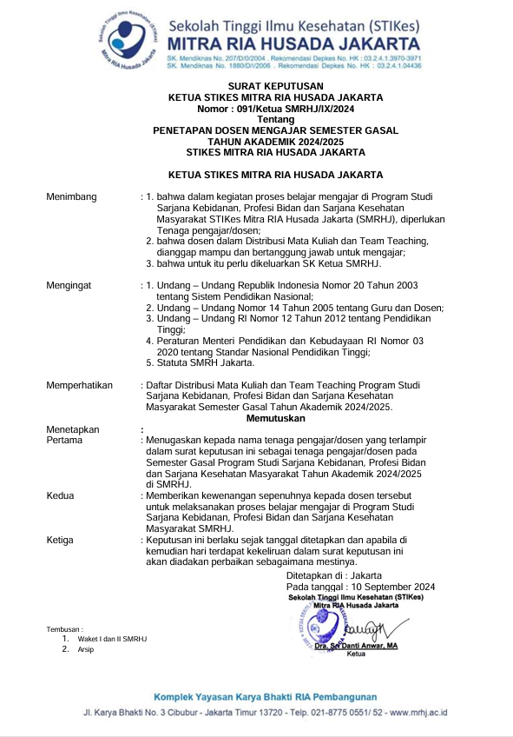

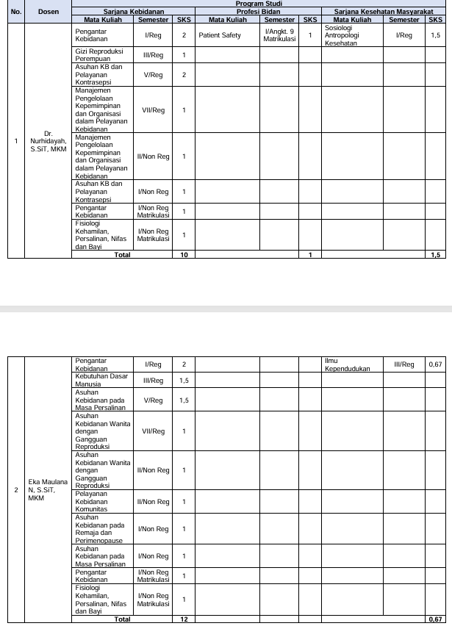

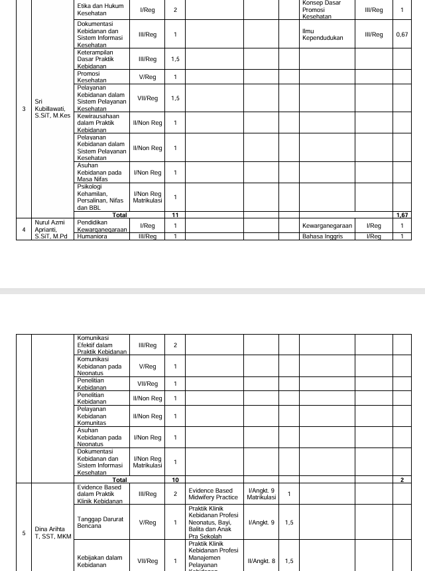

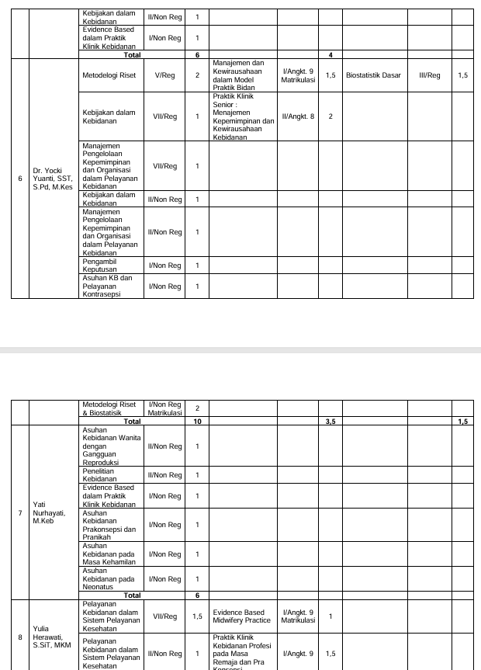

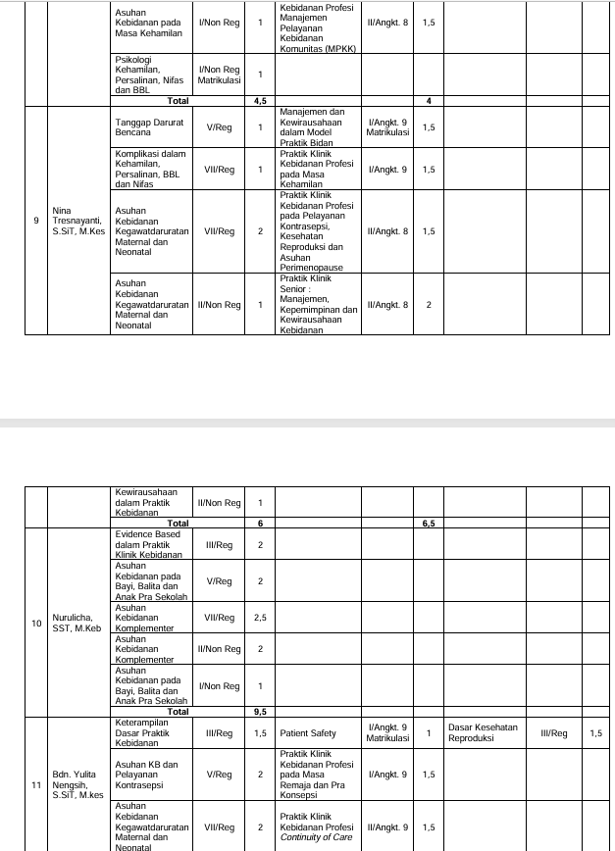

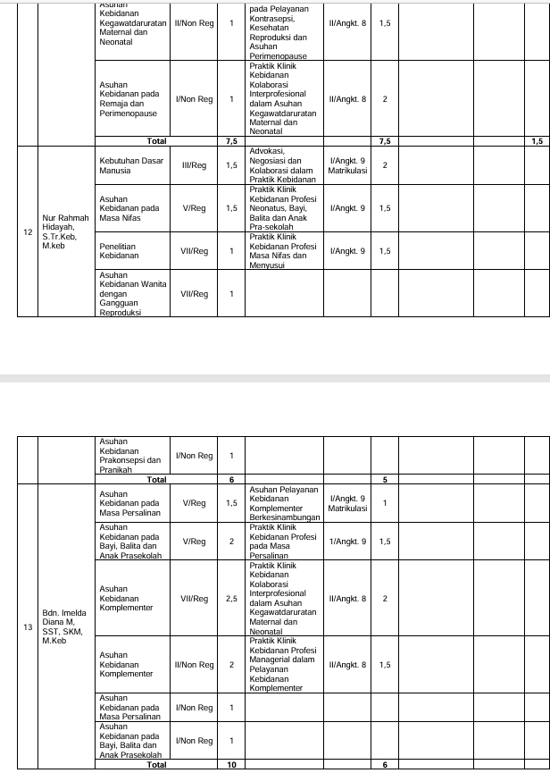

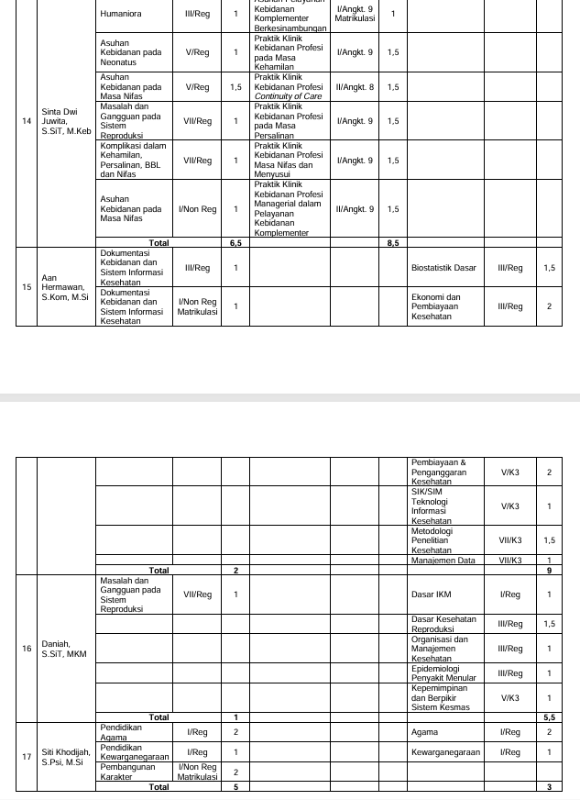

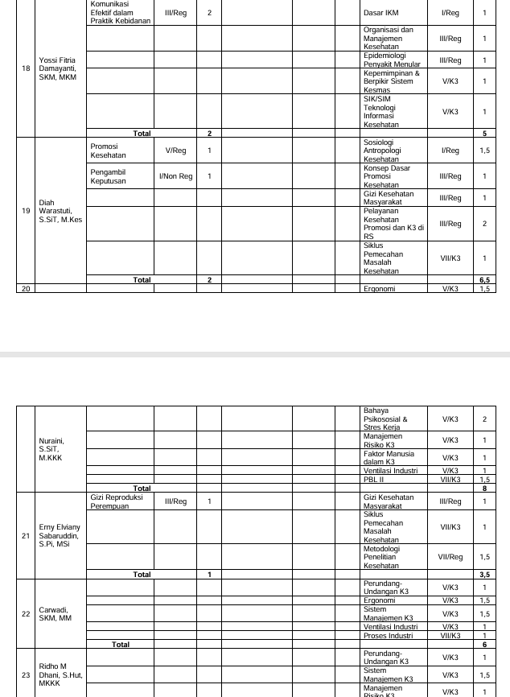

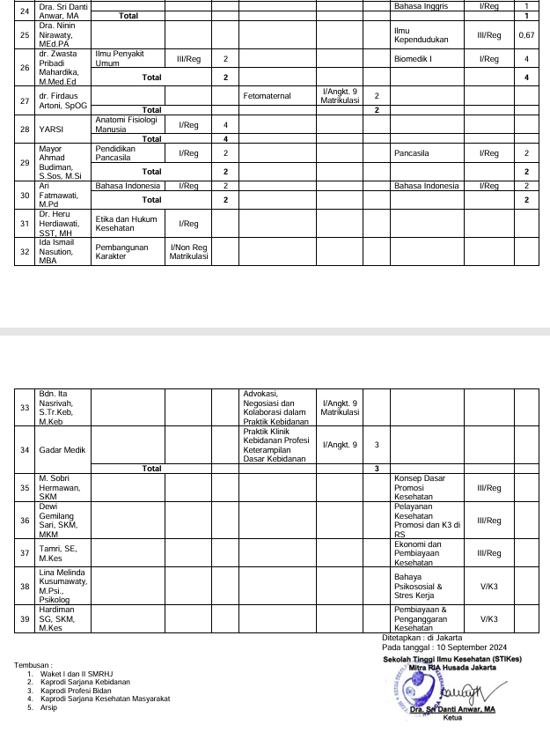

**NILAI PERKULIAHAN MAHASISWA**

|  |  |  |
| --- | --- | --- |
| **PRODI** | **:** | **S1 - KEBIDANAN** |
| **PERIODE** | **:** | **20241** |

|  |  |  |  |  |  |
| --- | --- | --- | --- | --- | --- |
| Mata kuliah | : | KOMPLIKASI DALAM KEHAMILAN, PERSALINAN, BBL DAN NIFAS | Nama Kelas | : | REG 7 |
| Kode Mata kuliah | : | BD63143 | SKS | : | 2 |

|  |  |  |  |  |  |  |  |  |  |  |  |  |
| --- | --- | --- | --- | --- | --- | --- | --- | --- | --- | --- | --- | --- |
| **No** | **NIM** | **Nama Mahasiswa** | **TUGAS INDIVIDU (25%)** | **QUIZ (10%)** | **PARTISIPAN (10%)** | **UTS (25%)** | **UAS (30%)** | **Nilai** | **Grade** | **Lulus** | **Sunting KRS?** | **Info** |
| 1 | 21404001 | MITHAHUL MAULA | 87.50 | 90.00 | 82.50 | 80.00 | 83.75 | 84.25 | A- | ✔ |  |  |
| 2 | 21404002 | IMELDA SALIM | 87.50 | 90.00 | 84.50 | 76.00 | 75.25 | 80.90 | B+ | ✔ |  |  |
| 3 | 21404003 | SHIFA SILVIANI | 87.50 | 90.00 | 91.50 | 84.00 | 97.50 | 90.28 | A | ✔ |  |  |
| 4 | 21404005 | FARA SABRINA OKTAVINATRY | 85.00 | 90.00 | 82.50 | 80.00 | 81.25 | 82.88 | A- | ✔ |  |  |
| 5 | 21404007 | DELLA AMELIA PUTRI | 85.00 | 85.00 | 87.50 | 75.00 | 77.50 | 80.50 | B+ | ✔ |  |  |
| 6 | 21404008 | IIS SITI AISAH | 87.50 | 85.00 | 84.00 | 74.00 | 76.25 | 80.15 | B+ | ✔ |  |  |
| 7 | 21404009 | ANANDA RIZKI SARI | 85.00 | 85.00 | 82.50 | 80.00 | 83.75 | 83.13 | A- | ✔ |  |  |
| 8 | 21404010 | SITI PATIMAH | 85.00 | 80.00 | 89.00 | 73.00 | 71.25 | 77.78 | B+ | ✔ |  |  |
| Tanggal Cetak : Senin, 13 Januari 2025, 15:26:52 | | | | | | | | | | | | | |
| Paraf Dosen : Yati Nurhayati, S.ST., M.KebE:\Prodi Profesi Bidan\Foto tanda tangan Yati.jpg Bdn. Sinta Dwi Juwita, S.SiT., M.Keb C:\Users\LAB_KEBIDANAN\Downloads\WhatsApp Image 2024-01-16 at 12.52.21.jpeg Nina Tresnayanti, S.Si.T., M.Kes | | | | | | | | | | | | | |

**LAPORAN PERSENTASE PRESENSI MAHASISWA  
S1 - KEBIDANAN  
20241**

|  |  |  |  |  |  |
| --- | --- | --- | --- | --- | --- |
| Mata kuliah | : | KOMPLIKASI DALAM KEHAMILAN, PERSALINAN, BBL DAN NIFAS | Nama Kelas | : | REG 7 |
| Dosen Pengajar | : | YATI NURHAYATI |  |  |  |

|  |  |  |  |  |  |  |  |  |
| --- | --- | --- | --- | --- | --- | --- | --- | --- |
| **No** | **NIM** | **Nama** | **Pertemuan** | **Alfa** | **Hadir** | **Ijin** | **Sakit** | **Presentase** |
| Peserta Reguler | | | | | | | | |
| 1 | 21404001 | MITHAHUL MAULA | 16 |  | 14 |  | 1 | 87.5 |
| 2 | 21404002 | IMELDA SALIM | 16 |  | 15 |  |  | 93.75 |
| 3 | 21404003 | SHIFA SILVIANI | 16 |  | 15 |  |  | 93.75 |
| 4 | 21404005 | FARA SABRINA OKTAVINATRY | 16 |  | 14 | 1 |  | 87.5 |
| 5 | 21404007 | DELLA AMELIA PUTRI | 16 |  | 13 |  | 2 | 81.25 |
| 6 | 21404008 | IIS SITI AISAH | 16 |  | 15 |  |  | 93.75 |
| 7 | 21404009 | ANANDA RIZKI SARI | 16 |  | 15 |  |  | 93.75 |
| 8 | 21404010 | SITI PATIMAH | 16 |  | 15 |  |  | 93.75 |

Jakarta, 13 Januari 2025  
Ketua Prodi S1 - Kebidanan  
  
Dr. NURHIDAYAH, S.SiT, MKM  
NIP. 0323057501



**ISI PRESENSI MAHASISWA  
S1 - KEBIDANAN  
20241**

|  |  |  |  |  |  |
| --- | --- | --- | --- | --- | --- |
| Mata kuliah | : | BD63143 - KOMPLIKASI DALAM KEHAMILAN, PERSALINAN, BBL DAN NIFAS | Nama Kelas | : | REG 7 |

|  |  |  |  |  |  |  |  |  |  |  |  |  |  |  |  |  |  |  |
| --- | --- | --- | --- | --- | --- | --- | --- | --- | --- | --- | --- | --- | --- | --- | --- | --- | --- | --- |
| **No** | **NIM** | **NAMA** | **TATAP MUKA** | | | | | | | | | | | | | | | |
| **17 Sep 2024** | **24 Sep 2024** | **1 Okt 2024** | **8 Okt 2024** | **15 Okt 2024** | **22 Okt 2024** | **29 Okt 2024** | **7 Nov 2024** | **12 Nov 2024** | **19 Nov 2024** | **26 Nov 2024** | **3 Des 2024** | **10 Des 2024** | **17 Des 2024** | **9 Jan 2025** |
| Peserta Reguler | | | | | | | | | | | | | | | | | | |
| 1 | 21404001 | MITHAHUL MAULA | H | H | H | H | H | H | H | H | H | S | H | H | H | H | H |
| 2 | 21404002 | IMELDA SALIM | H | H | H | H | H | H | H | H | H | H | H | H | H | H | H |
| 3 | 21404003 | SHIFA SILVIANI | H | H | H | H | H | H | H | H | H | H | H | H | H | H | H |
| 4 | 21404005 | FARA SABRINA OKTAVINATRY | H | H | H | H | I | H | H | H | H | H | H | H | H | H | H |
| 5 | 21404007 | DELLA AMELIA PUTRI | H | H | H | H | H | H | H | H | H | S | H | S | H | H | H |
| 6 | 21404008 | IIS SITI AISAH | H | H | H | H | H | H | H | H | H | H | H | H | H | H | H |
| 7 | 21404009 | ANANDA RIZKI SARI | H | H | H | H | H | H | H | H | H | H | H | H | H | H | H |
| 8 | 21404010 | SITI PATIMAH | H | H | H | H | H | H | H | H | H | H | H | H | H | H | H |
| **Paraf Ketua Kelas** | | |  | | | | | | | | | | | | | | | |
| **Paraf Dosen** | | |  | | | | | | | | | | | | | | | |

**ISI PRESENSI DOSEN  
S1 - KEBIDANAN  
20241**

|  |  |  |  |  |  |
| --- | --- | --- | --- | --- | --- |
| Mata kuliah | : | BD63143 - KOMPLIKASI DALAM KEHAMILAN, PERSALINAN, BBL DAN NIFAS | Nama Kelas | : | REG 7 |

|  |  |  |  |  |  |  |  |  |  |  |  |  |  |  |  |  |  |  |
| --- | --- | --- | --- | --- | --- | --- | --- | --- | --- | --- | --- | --- | --- | --- | --- | --- | --- | --- |
| **No** | **NIP** | **NAMA** | **TATAP MUKA** | | | | | | | | | | | | | | | |
| **17 Sep 2024** | **24 Sep 2024** | **1 Okt 2024** | **8 Okt 2024** | **15 Okt 2024** | **22 Okt 2024** | **29 Okt 2024** | **7 Nov 2024** | **12 Nov 2024** | **19 Nov 2024** | **26 Nov 2024** | **3 Des 2024** | **10 Des 2024** | **17 Des 2024** | **24 Des 2024** | **9 Jan 2025** |
| 1 | 190223466 | YATI NURHAYATI |  |  |  |  |  |  |  | E:\Prodi Profesi Bidan\Foto tanda tangan Yati.jpg |  |  |  |  |  |  |  | E:\Prodi Profesi Bidan\Foto tanda tangan Yati.jpg |
| 2 | 0318039501 | Bdn. Sinta Dwi Juwita, S.SiT., M.Keb |  |  |  |  |  |  |  |  |  |  |  |  |  |  |  |  |
| 3 | 0327057502 | NINA TRESNAYANTI, S.SiT, M.Kes |  |  |  |  |  |  |  |  |  |  |  |  |  |  |  |  |