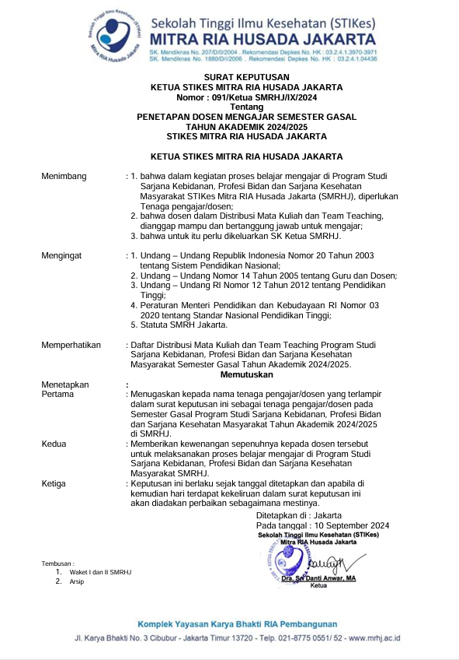

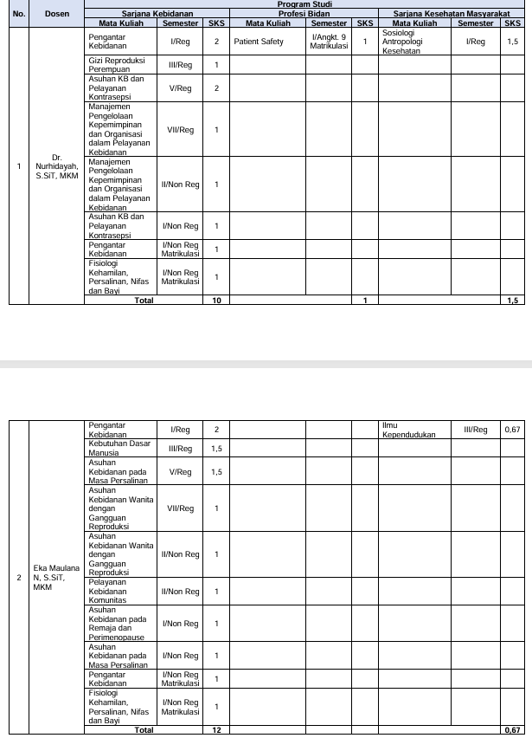

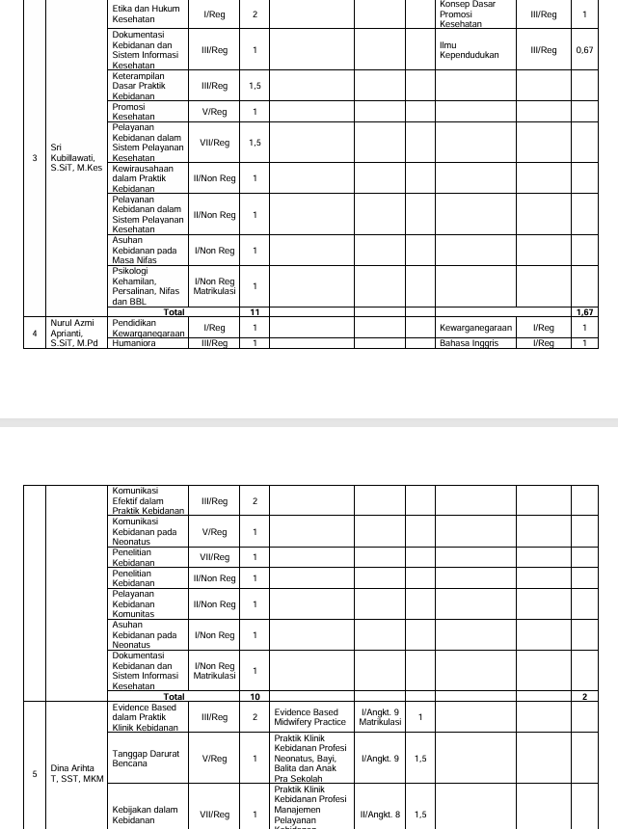

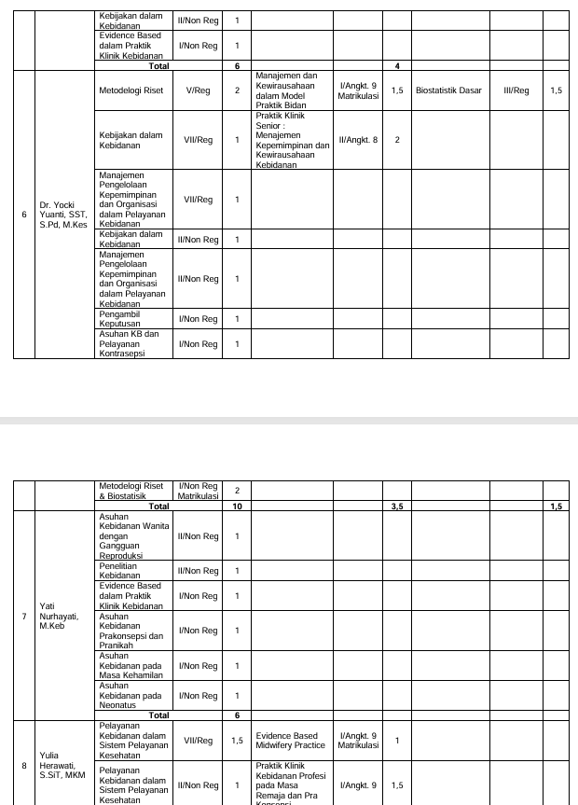

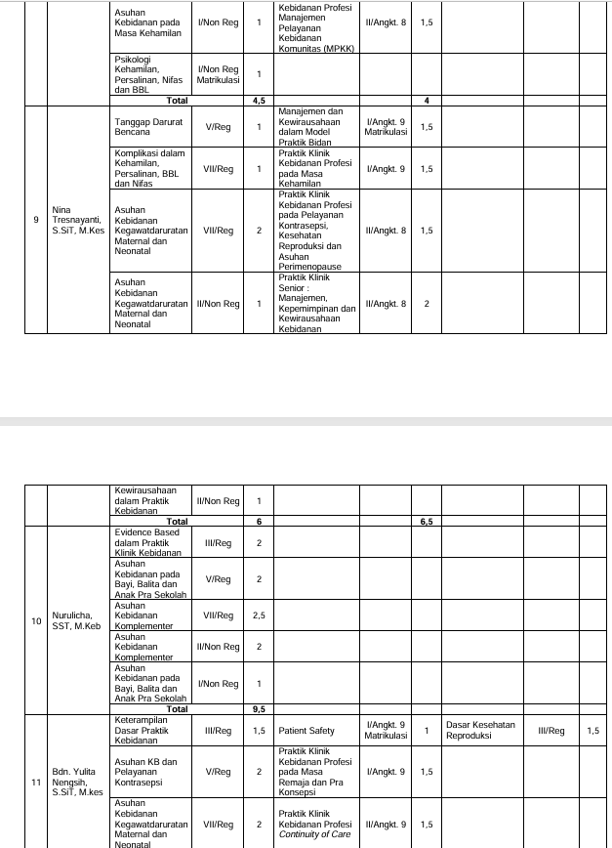

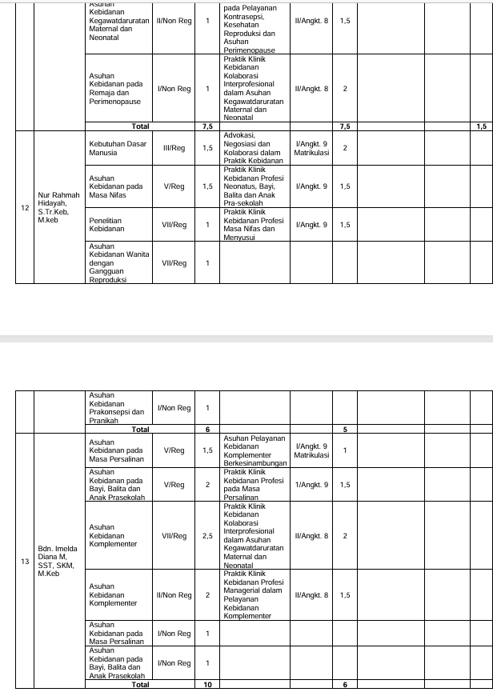

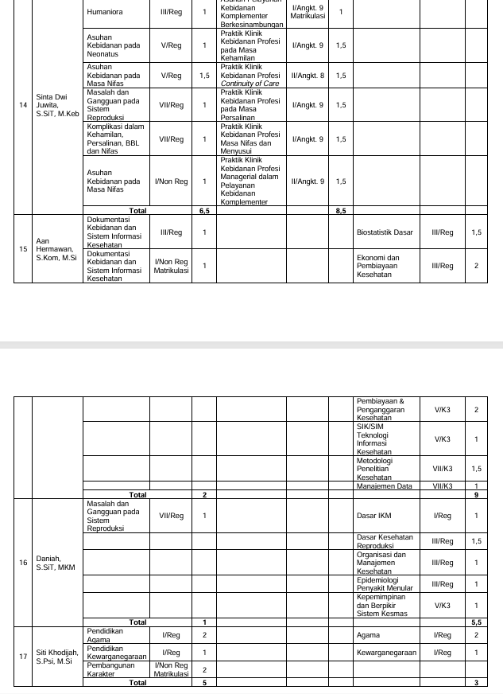

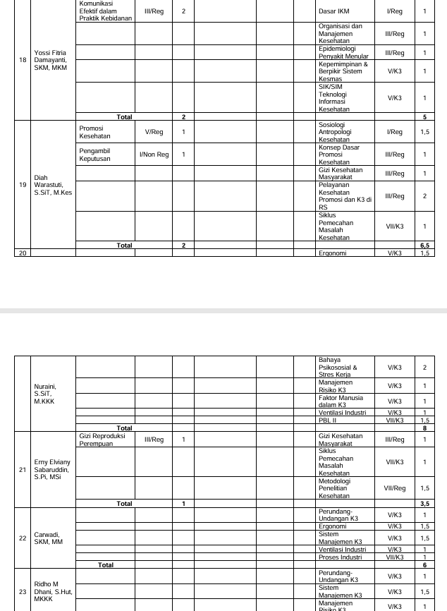

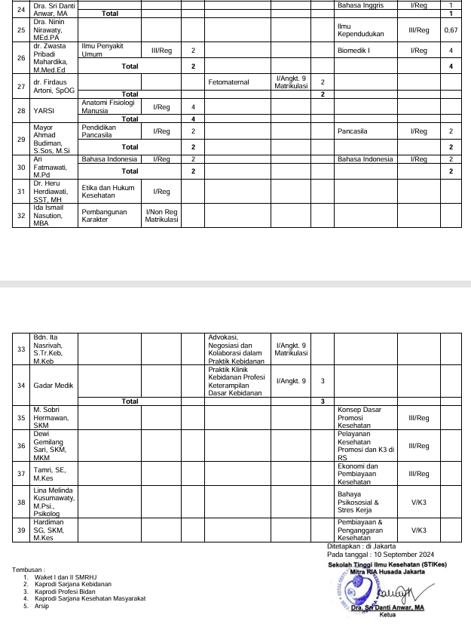

**LAPORAN PERSENTASE PRESENSI MAHASISWA  
S1 - KEBIDANAN  
20241**

|  |  |  |  |  |  |
| --- | --- | --- | --- | --- | --- |
| Mata kuliah | : | EVIDENCE BASED DALAM PRAKTIK KLINIK KEBIDANAN | Nama Kelas | : | REG 3 |
| Dosen Pengajar | : | YATI NURHAYATI |  |  |  |

|  |  |  |  |  |  |  |  |  |
| --- | --- | --- | --- | --- | --- | --- | --- | --- |
| **No** | **NIM** | **Nama** | **Pertemuan** | **Alfa** | **Hadir** | **Ijin** | **Sakit** | **Presentase** |
| Peserta Reguler | | | | | | | | |
| 1 | 23405001 | NISA AYUNI | 16 |  | 16 |  |  | 100 |
| 2 | 23405002 | IRMA CHINDIANA | 16 |  | 15 | 1 |  | 93.75 |
| 3 | 23405003 | NURUNNISA HAADIYATURRAHMAH | 16 |  | 16 |  |  | 100 |
| 4 | 23405004 | ERISKA SANDRA | 16 |  | 16 |  |  | 100 |
| 5 | 23405005 | MUTIARA ZILVANIA RAHAYU H | 16 |  | 16 |  |  | 100 |
| 6 | 23405007 | ANITA ACHMELIA | 16 |  | 16 |  |  | 100 |
| 7 | 23405008 | ENUR NURJANAH | 16 |  | 16 |  |  | 100 |
| 8 | 23405009 | ZULFA ANGGRAINI | 16 |  | 16 |  |  | 100 |
| 9 | 23405010 | EUIS FATMAWATI | 16 |  | 16 |  |  | 100 |

Jakarta, 16 Januari 2025  
Ketua Prodi S1 - Kebidanan  
  
Dr. NURHIDAYAH, S.SiT, MKM  
NIP. 0323057501



Dicetak oleh: YATI NURHAYATI, pada 16 Januari 2025 15:42:14 WIB | stikesmrh.siakadcloud.com/siakad/rep\_prosentaseabs

**ISI PRESENSI DOSEN  
S1 - KEBIDANAN  
20241**

|  |  |  |  |  |  |
| --- | --- | --- | --- | --- | --- |
| Mata kuliah | : | BD62103. - EVIDENCE BASED DALAM PRAKTIK KLINIK KEBIDANAN | Nama Kelas | : | REG 3 |

|  |  |  |  |  |  |  |  |  |  |  |  |  |  |  |  |  |  |  |
| --- | --- | --- | --- | --- | --- | --- | --- | --- | --- | --- | --- | --- | --- | --- | --- | --- | --- | --- |
| **No** | **NIP** | **NAMA** | **TATAP MUKA** | | | | | | | | | | | | | | | |
| **19 Sep 2024** | **26 Sep 2024** | **3 Okt 2024** | **10 Okt 2024** | **17 Okt 2024** | **24 Okt 2024** | **31 Okt 2024** | **6 Nov 2024** | **14 Nov 2024** | **21 Nov 2024** | **28 Nov 2024** | **5 Des 2024** | **12 Des 2024** | **19 Des 2024** | **26 Des 2024** | **5 Jan 2025** |
| 1 | 190223466 | YATI NURHAYATI |  |  |  |  |  |  |  |  |  |  |  |  |  |  |  |  |
| 2 | 0126108001 | DINA ARIHTA TARIGAN, SST, MKM |  |  |  |  |  | C:\Users\Dina Martha\Downloads\ttd 15-Sep-2020 08-20-33_page-0001.jpg | C:\Users\Dina Martha\Downloads\ttd 15-Sep-2020 08-20-33_page-0001.jpg |  | C:\Users\Dina Martha\Downloads\ttd 15-Sep-2020 08-20-33_page-0001.jpg | C:\Users\Dina Martha\Downloads\ttd 15-Sep-2020 08-20-33_page-0001.jpg | C:\Users\Dina Martha\Downloads\ttd 15-Sep-2020 08-20-33_page-0001.jpg | C:\Users\Dina Martha\Downloads\ttd 15-Sep-2020 08-20-33_page-0001.jpg | C:\Users\Dina Martha\Downloads\ttd 15-Sep-2020 08-20-33_page-0001.jpg | C:\Users\Dina Martha\Downloads\ttd 15-Sep-2020 08-20-33_page-0001.jpg | C:\Users\Dina Martha\Downloads\ttd 15-Sep-2020 08-20-33_page-0001.jpg |  |
| 3 | 0426028401 | NURULICHA, SST, M.Keb | D:\DATA - DATA\TTD SAYA.jpg | D:\DATA - DATA\TTD SAYA.jpg | D:\DATA - DATA\TTD SAYA.jpg | D:\DATA - DATA\TTD SAYA.jpg | D:\DATA - DATA\TTD SAYA.jpg |  |  |  |  |  |  |  |  |  |  |  |

**NILAI PERKULIAHAN MAHASISWA**

|  |  |  |
| --- | --- | --- |
| **PRODI** | **:** | **S1 - KEBIDANAN** |
| **PERIODE** | **:** | **20241** |

|  |  |  |  |  |  |
| --- | --- | --- | --- | --- | --- |
| Mata kuliah | : | EVIDENCE BASED DALAM PRAKTIK KLINIK KEBIDANAN | Nama Kelas | : | REG 3 |
| Kelas / Kelompok | : |  |  |  |  |
| Kode Mata kuliah | : | BD62103. | SKS | : | 4 |
|  |  |  |  |  |  |

|  |  |  |  |  |  |  |  |  |  |  |
| --- | --- | --- | --- | --- | --- | --- | --- | --- | --- | --- |
| **No** | **NIM** | **Nama Mahasiswa** | **TUGAS INDIVIDU (25%)** | **QUIZ (10%)** | **PARTISIPAN (10%)** | **UTS (25%)** | **UAS (30%)** | **Nilai** | **Grade** | **Lulus** |
| 1 | 23405001 | NISA AYUNI | 85.00 | 82.50 | 95.00 | 89.00 | 80.00 | 85.25 | A- | ✔ |
| 2 | 23405002 | IRMA CHINDIANA | 80.00 | 79.00 | 95.00 | 79.00 | 79.25 | 80.93 | B+ | ✔ |
| 3 | 23405003 | NURUNNISA HAADIYATURRAHMAH | 78.00 | 79.50 | 95.00 | 88.00 | 80.75 | 83.18 | A- | ✔ |
| 4 | 23405004 | ERISKA SANDRA | 76.00 | 77.00 | 95.00 | 80.00 | 75.00 | 78.70 | B+ | ✔ |
| 5 | 23405005 | MUTIARA ZILVANIA RAHAYU H | 90.00 | 80.50 | 95.00 | 85.00 | 79.00 | 85.00 | A- | ✔ |
| 6 | 23405007 | ANITA ACHMELIA | 73.00 | 75.00 | 95.00 | 79.00 | 77.50 | 78.25 | B+ | ✔ |
| 7 | 23405008 | ENUR NURJANAH | 85.00 | 76.50 | 95.00 | 80.00 | 77.50 | 81.65 | A- | ✔ |
| 8 | 23405009 | ZULFA ANGGRAINI | 72.00 | 77.00 | 95.00 | 77.00 | 77.00 | 77.55 | B+ | ✔ |
| 9 | 23405010 | EUIS FATMAWATI | 75.00 | 74.50 | 95.00 | 78.00 | 76.50 | 78.15 | B+ | ✔ |
| Tanggal Cetak : Kamis, 16 Januari 2025, 15:40:21 | | | | | | | | | | |
| Paraf Dosen : YATI NURHAYATI, S.ST., M.Keb  DINA ARIHTA TARIGAN, SST, MKMC:\Users\Dina Martha\Downloads\ttd 15-Sep-2020 08-20-33_page-0001.jpg NURULICHA, SST, M.KebD:\DATA - DATA\TTD SAYA.jpg | | | | | | | | | | |