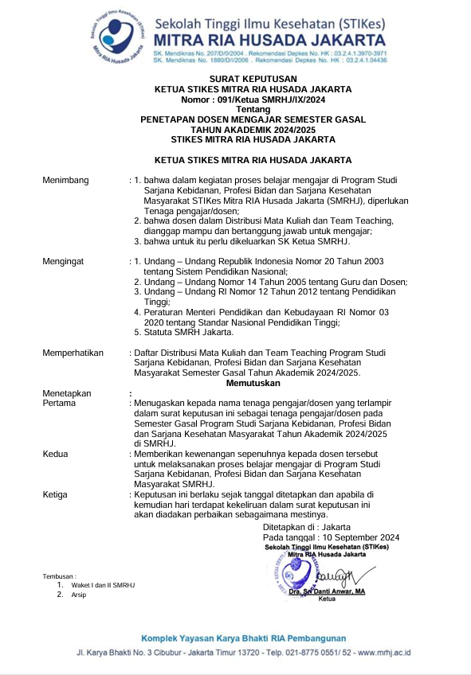

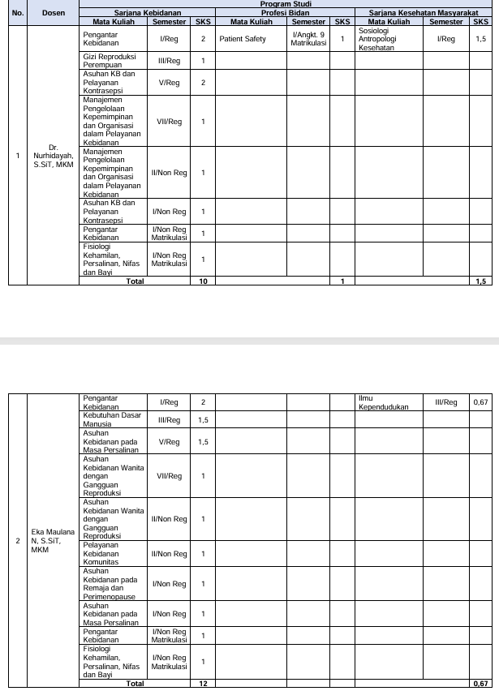

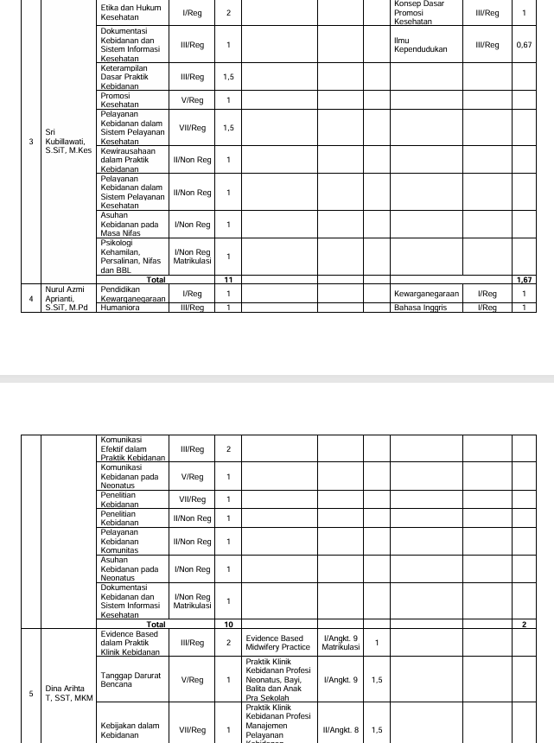

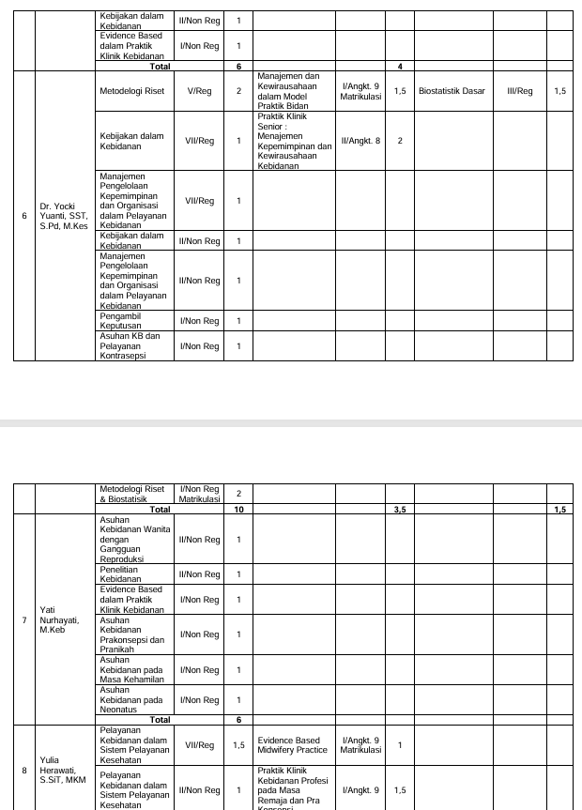

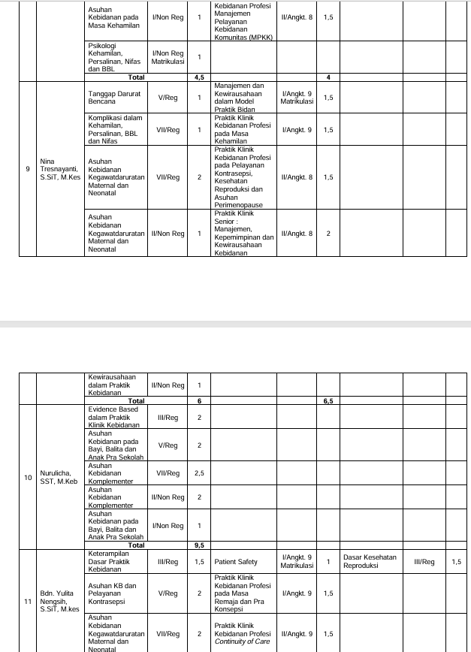

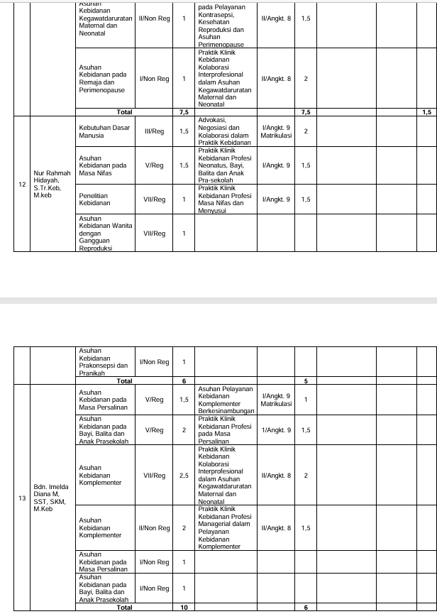

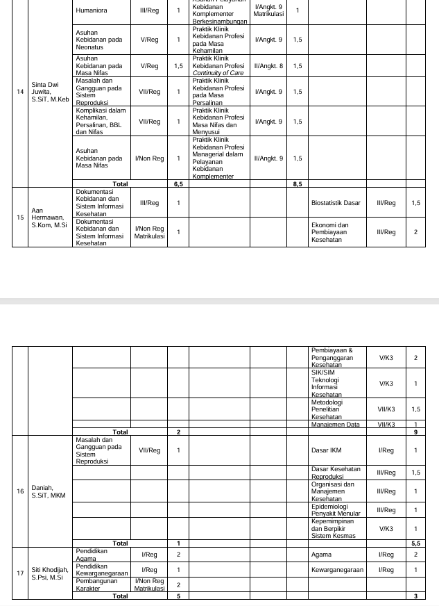

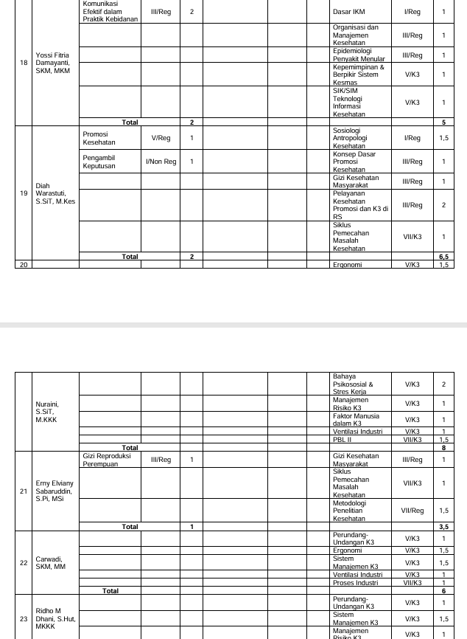

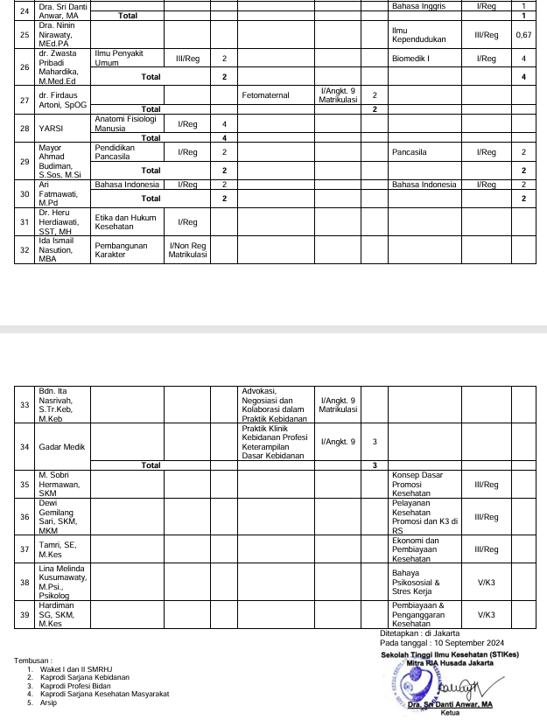

**NILAI PERKULIAHAN MAHASISWA**

|  |  |  |
| --- | --- | --- |
| **PRODI** | **:** | **S1 - KEBIDANAN** |
| **PERIODE** | **:** | **20241** |

|  |  |  |  |  |  |
| --- | --- | --- | --- | --- | --- |
| Mata kuliah | : | EVIDENCE BASED DALAM PRAKTIK KLINIK KEBIDANAN | Nama Kelas | : | 1 A |
| Kelas / Kelompok | : |  |  |  |  |
| Kode Mata kuliah | : | BD62103 | SKS | : | 2 |

|  |  |  |  |  |  |  |  |  |  |  |
| --- | --- | --- | --- | --- | --- | --- | --- | --- | --- | --- |
| **No** | **NIM** | **Nama Mahasiswa** | **TUGAS INDIVIDU (25%)** | **QUIZ (10%)** | **PARTISIPAN (10%)** | **UTS (25%)** | **UAS (30%)** | **Nilai** | **Grade** | **Lulus** |
| 1 | 24505001 | RISA YULIYANTI | 75.00 | 80.00 | 90.00 | 50.00 | 76.00 | 71.05 | B | ✔ |
| 2 | 24505002 | MUNAWATI | 75.00 | 75.00 | 90.00 | 47.00 | 80.00 | 71.00 | B | ✔ |
| 3 | 24505007 | DEWI SIPA MENTARI | 75.00 | 75.00 | 90.00 | 60.00 | 85.00 | 75.75 | B | ✔ |
| 4 | 24505008 | NENG NUROHIMAH | 75.00 | 90.00 | 90.00 | 63.00 | 87.00 | 78.60 | B+ | ✔ |
| 5 | 24505009 | KHAEVA ABDALELA | 90.00 | 75.00 | 90.00 | 65.00 | 84.00 | 80.45 | B+ | ✔ |
| 6 | 24505012 | DESI MULYANI | 75.00 | 75.00 | 90.00 | 70.00 | 82.00 | 77.35 | B+ | ✔ |
| 7 | 24505013 | HERLIYANI | 75.00 | 72.00 | 90.00 | 55.00 | 89.00 | 75.40 | B | ✔ |
| 8 | 24505014 | DEWI PURNAMA | 75.00 | 75.00 | 90.00 | 59.00 | 70.00 | 71.00 | B | ✔ |
| 9 | 24505015 | SITI FAUZIAH | 90.00 | 72.00 | 90.00 | 65.00 | 97.00 | 84.05 | A- | ✔ |
| 10 | 24505016 | IIS RISDIYANTI | 75.00 | 100.00 | 95.00 | 68.00 | 77.00 | 78.35 | B+ | ✔ |
| 11 | 24505017 | HENI AWALIYAH | 75.00 | 100.00 | 90.00 | 68.00 | 89.00 | 81.45 | A- | ✔ |
| 12 | 24505018 | LELIS NURLAELI | 90.00 | 72.00 | 90.00 | 70.00 | 75.00 | 78.70 | B+ | ✔ |
| 13 | 24505019 | YUYU YUNIARTI | 75.00 | 72.00 | 90.00 | 65.00 | 84.00 | 76.40 | B+ | ✔ |
| 14 | 24505020 | FIRNA RIZNI PARAMITHA | 90.00 | 72.00 | 90.00 | 95.00 | 84.00 | 87.65 | A | ✔ |
| 15 | 24505021 | DESI AMALIA PANDINI | 75.00 | 72.00 | 90.00 | 85.00 | 70.00 | 77.20 | B+ | ✔ |
| 16 | 24505022 | YETI SETIAWATI | 75.00 | 70.00 | 90.00 | 95.00 | 78.00 | 81.90 | A- | ✔ |
| 17 | 24505023 | DESI LUIS ALPIONITA | 75.00 | 70.00 | 90.00 | 95.00 | 79.00 | 82.20 | A- | ✔ |
| 18 | 24505024 | CUCU ROSITA | 90.00 | 70.00 | 95.00 | 95.00 | 77.00 | 85.85 | A- | ✔ |
| 19 | 24505025 | IRMA NURPATIHAH | 90.00 | 72.00 | 90.00 | 95.00 | 88.00 | 88.85 | A | ✔ |
| 20 | 24505026 | NOVI LUSIANDI | 90.00 | 72.00 | 90.00 | 95.00 | 72.00 | 84.05 | A- | ✔ |
| 21 | 24505027 | ROHESIH | 75.00 | 75.00 | 90.00 | 95.00 | 63.00 | 77.90 | B+ | ✔ |
| 22 | 24505029 | EVA KOMALASARI | 90.00 | 85.00 | 90.00 | 90.00 | 85.00 | 88.00 | A | ✔ |
| 23 | 24505031 | EVA LESTARI | 75.00 | 79.00 | 98.00 | 70.00 | 70.00 | 74.95 | B | ✔ |
| 24 | 24505032 | NENGSIH MIYATI | 75.00 | 80.00 | 90.00 | 60.00 | 71.00 | 72.05 | B | ✔ |
| 25 | 24505034 | RATU RESTI CAHYANI | 90.00 | 72.00 | 90.00 | 65.00 | 63.00 | 73.85 | B | ✔ |
| 26 | 24505037 | DEDE ELIA FEBRIANI | 90.00 | 78.00 | 90.00 | 80.00 | 76.00 | 82.10 | A- | ✔ |
| 27 | 24505038 | RIFA AULIA | 75.00 | 72.00 | 90.00 | 59.00 | 71.00 | 71.00 | B | ✔ |
| 28 | 24505043 | ERFA HERLINSYAH | 90.00 | 70.00 | 90.00 | 73.00 | 76.00 | 79.55 | B+ | ✔ |
| 29 | 24505044 | IRMA NIRMALA | 90.00 | 70.00 | 90.00 | 63.00 | 91.00 | 81.55 | A- | ✔ |
| 30 | 24505055 | YULI APRIANTI | 75.00 | 70.00 | 90.00 | 95.00 | 81.00 | 82.80 | A- | ✔ |
| 31 | 24505056 | RITA ROSDIANA | 95.00 | 90.00 | 100.00 | 93.00 | 70.00 | 87.00 | A | ✔ |
| 32 | 24505058 | TITIN PUSPITASARI | 90.00 | 72.00 | 90.00 | 68.00 | 85.00 | 81.20 | A- | ✔ |
| 33 | 24505060 | NISA MULYAWATI | 90.00 | 65.00 | 90.00 | 85.00 | 76.00 | 82.05 | A- | ✔ |
| 34 | 24505061 | ILMA NOOR AJIZAH | 75.00 | 75.00 | 90.00 | 71.00 | 60.00 | 71.00 | B | ✔ |
| 35 | 24505065 | DITA DWI TAFRINA | 75.00 | 67.00 | 90.00 | 98.00 | 88.00 | 85.35 | A- | ✔ |
| 36 | 24505073 | NINING KARLINA | 75.00 | 75.00 | 90.00 | 75.00 | 80.00 | 78.00 | B+ | ✔ |
| 37 | 24505076 | AI IMAS JAMILLAH | 72.00 | 90.00 | 90.00 | 70.00 | 81.00 | 77.80 | B+ | ✔ |

|  |
| --- |
| Tanggal Cetak : Selasa, 21 Januari 2025, 10:14:48 |
| Paraf Dosen : YATI NURHAYATI, S.ST., M.Keb E:\Prodi Profesi Bidan\Foto tanda tangan Yati.jpg DINA ARIHTA TARIGAN, SST, MKM C:\Users\Dina Martha\Downloads\ttd 15-Sep-2020 08-20-33_page-0001.jpg |

**NILAI PERKULIAHAN MAHASISWA**

|  |  |  |
| --- | --- | --- |
| **PRODI** | **:** | **S1 - KEBIDANAN** |
| **PERIODE** | **:** | **20241** |

|  |  |  |  |  |  |
| --- | --- | --- | --- | --- | --- |
| Mata kuliah | : | EVIDENCE BASED DALAM PRAKTIK KLINIK KEBIDANAN | Nama Kelas | : | 1 B |
| Kelas / Kelompok | : |  |  |  |  |
| Kode Mata kuliah | : | BD62103 | SKS | : | 2 |

|  |  |  |  |  |  |  |  |  |  |  |
| --- | --- | --- | --- | --- | --- | --- | --- | --- | --- | --- |
| **No** | **NIM** | **Nama Mahasiswa** | **TUGAS INDIVIDU (25%)** | **QUIZ (10%)** | **PARTISIPAN (10%)** | **UTS (25%)** | **UAS (30%)** | **Nilai** | **Grade** | **Lulus** |
| 1 | 23504059 | EMI TINEKE PETRONELA TAIME | 75.00 | 75.00 | 88.00 | 60.00 | 70.00 | 71.05 | B | ✔ |
| 2 | 24505003 | FAZRIAH NABILAH AL FAUZIAH SYAHDA | 90.00 | 80.00 | 90.00 | 90.00 | 73.00 | 83.90 | A- | ✔ |
| 3 | 24505004 | MANAL | 75.00 | 75.00 | 90.00 | 60.00 | 73.00 | 72.15 | B | ✔ |
| 4 | 24505005 | MEILAWATI PUTRI PRATIWI | 75.00 | 90.00 | 90.00 | 65.00 | 92.00 | 80.60 | B+ | ✔ |
| 5 | 24505006 | CAHAYA LINTANG PRIMA DIGDAYA | 75.00 | 60.00 | 90.00 | 60.00 | 86.00 | 74.55 | B | ✔ |
| 6 | 24505010 | YUHANIPA | 75.00 | 70.00 | 90.00 | 59.00 | 72.00 | 71.10 | B | ✔ |
| 7 | 24505011 | SHINTIYA LOREN | 75.00 | 70.00 | 90.00 | 49.00 | 80.00 | 71.00 | B | ✔ |
| 8 | 24505028 | DEBY ANISSA | 75.00 | 70.00 | 90.00 | 90.00 | 77.00 | 80.35 | B+ | ✔ |
| 9 | 24505030 | SILPI NOPIANTI | 75.00 | 60.00 | 90.00 | 65.00 | 80.00 | 74.00 | B | ✔ |
| 10 | 24505033 | SITI HANA VITA | 75.00 | 75.00 | 90.00 | 63.00 | 79.00 | 74.70 | B | ✔ |
| 11 | 24505035 | REGINA MULYASARI | 75.00 | 80.00 | 90.00 | 51.00 | 75.00 | 71.00 | B | ✔ |
| 12 | 24505036 | UUM UMBARAWATI LARA DEWI | 75.00 | 70.00 | 95.00 | 59.00 | 70.00 | 71.00 | B | ✔ |
| 13 | 24505039 | AYU SIMAREMARE | 70.00 | 70.00 | 95.00 | 68.00 | 70.00 | 72.00 | B | ✔ |
| 14 | 24505040 | NABIILAH NA'FA LABI'BAH | 76.00 | 76.00 | 94.00 | 47.00 | 78.00 | 71.15 | B | ✔ |
| 15 | 24505041 | AYU SRI WAHYUNI | 75.00 | 75.00 | 90.00 | 59.00 | 70.00 | 71.00 | B | ✔ |
| 16 | 24505042 | NINA ROSMAWATI | 75.00 | 65.00 | 90.00 | 85.00 | 81.00 | 79.80 | B+ | ✔ |
| 17 | 24505045 | RENISA BUNGA NATASYA | 75.00 | 60.00 | 90.00 | 65.00 | 70.00 | 71.00 | B | ✔ |
| 18 | 24505046 | MERRY GUSTIANA SAID | 90.00 | 65.00 | 90.00 | 78.00 | 85.00 | 83.00 | A- | ✔ |
| 19 | 24505047 | SITI ELISA | 75.00 | 70.00 | 90.00 | 60.00 | 79.00 | 73.45 | B | ✔ |
| 20 | 24505048 | RISKA RISMAYANTI RIDWAN | 75.00 | 98.00 | 90.00 | 58.00 | 70.00 | 73.05 | B | ✔ |
| 21 | 24505049 | DINDA MUTI ANGGELA | 75.00 | 60.00 | 90.00 | 73.00 | 70.00 | 73.00 | B | ✔ |
| 22 | 24505050 | DIAN NURMASARI | 90.00 | 75.00 | 90.00 | 93.00 | 72.00 | 83.85 | A- | ✔ |
| 23 | 24505051 | MAGHFIRAH | 75.00 | 95.00 | 95.00 | 93.00 | 85.00 | 86.50 | A | ✔ |
| 24 | 24505052 | YULI INDRA SETIYO LESTARI | 90.00 | 95.00 | 90.00 | 78.00 | 79.00 | 84.20 | A- | ✔ |
| 25 | 24505053 | VELLA EFIANA | 75.00 | 70.00 | 90.00 | 68.00 | 88.00 | 78.15 | B+ | ✔ |
| 26 | 24505054 | NURYANTI | 95.00 | 65.00 | 90.00 | 90.00 | 83.00 | 86.65 | A | ✔ |
| 27 | 24505057 | AYU ASTIKA PARWI | 95.00 | 80.00 | 90.00 | 55.00 | 80.00 | 78.50 | B+ | ✔ |
| 28 | 24505059 | DIAN NURLELA | 95.00 | 65.00 | 90.00 | 48.00 | 85.00 | 76.75 | B+ | ✔ |
| 29 | 24505062 | SUSI AYUNINGSIH | 95.00 | 100.00 | 90.00 | 58.00 | 70.00 | 78.25 | B+ | ✔ |
| 30 | 24505063 | NEUIS MALIHAH | 95.00 | 65.00 | 90.00 | 70.00 | 91.00 | 84.05 | A- | ✔ |
| 31 | 24505064 | JULLY LATUHIHIN | 95.00 | 70.00 | 90.00 | 98.00 | 80.00 | 88.25 | A | ✔ |
| 32 | 24505066 | PUTRI LATIFAH | 75.00 | 75.00 | 90.00 | 80.00 | 70.00 | 76.25 | B+ | ✔ |
| 33 | 24505067 | DINI HANDAYANI | 75.00 | 80.00 | 90.00 | 75.00 | 88.00 | 80.90 | B+ | ✔ |
| 34 | 24505068 | AMIRA RAFIKA SARI | 75.00 | 100.00 | 90.00 | 60.00 | 70.00 | 73.75 | B | ✔ |
| 35 | 24505069 | AGISNI SARI | 75.00 | 60.00 | 90.00 | 68.00 | 79.00 | 74.45 | B | ✔ |
| 36 | 24505070 | SAMSUDDUHA CIRIMAI PUTRI | 75.00 | 100.00 | 90.00 | 55.00 | 70.00 | 72.50 | B | ✔ |
| 37 | 24505071 | AI SRI WIDIAWATI | 90.00 | 90.00 | 90.00 | 70.00 | 85.00 | 83.50 | A- | ✔ |
| 38 | 24505072 | BUNGA SALIA RAHMAWATI | 70.00 | 60.00 | 90.00 | 63.00 | 81.00 | 72.55 | B | ✔ |
| 39 | 24505075 | RIBKA JUNITA YOKU | 90.00 | 60.00 | 90.00 | 50.00 | 70.00 | 71.00 | B | ✔ |
| 40 | 24505077 | DEA AYU FRASTICA | 70.00 | 77.00 | 90.00 | 70.00 | 70.00 | 72.70 | B | ✔ |
| 41 | 24505078 | DORCI YEUW | 75.00 | 60.00 | 90.00 | 88.00 | 78.00 | 79.15 | B+ | ✔ |

|  |
| --- |
| Tanggal Cetak : Selasa, 21 Januari 2025, 10:14:48 |
| Paraf Dosen : YATI NURHAYATI, S.ST., M.Keb E:\Prodi Profesi Bidan\Foto tanda tangan Yati.jpg DINA ARIHTA TARIGAN, SST, MKM C:\Users\Dina Martha\Downloads\ttd 15-Sep-2020 08-20-33_page-0001.jpg |

**ABSENSI DOSEN DAN MAHASISWA**

**ISI PRESENSI DOSEN S1 – KEBIDANAN 20241**

|  |  |  |  |  |  |
| --- | --- | --- | --- | --- | --- |
| Mata kuliah | : | BD62103 - EVIDENCE BASED DALAM PRAKTIK KLINIK KEBIDANAN | Nama Kelas | : | 1 A |

|  |  |  |  |  |  |  |  |  |  |  |  |  |  |  |  |  |  |  |
| --- | --- | --- | --- | --- | --- | --- | --- | --- | --- | --- | --- | --- | --- | --- | --- | --- | --- | --- |
| **No** | **NIP** | **NAMA** | **TATAP MUKA** | | | | | | | | | | | | | | | |
| **21 Sep 2024** | **28 Sep 2024** | **5 Okt 2024** | **12 Okt 2024** | **19 Okt 2024** | **26 Okt 2024** | **2 Nov 2024** | **4 Nov 2024** | **16 Nov 2024** | **23 Nov 2024** | **30 Nov 2024** | **7 Des 2024** | **14 Des 2024** | **21 Des 2024** | **28 Des 2024** | **7 Jan 2025** |
| 1 | 190223466 | YATI NURHAYATI | H | H | H | H | H | H | H | H |  |  |  |  |  |  |  |  |
| 2 | 0126108001 | DINA ARIHTA TARIGAN, SST, MKM |  |  |  |  |  |  |  |  | H | H | H | H | H | H | H | H |

**LAPORAN PERSENTASE PRESENSI MAHASISWA  
S1 - KEBIDANAN  
20241**

|  |  |  |  |  |  |
| --- | --- | --- | --- | --- | --- |
| Mata kuliah | : | EVIDENCE BASED DALAM PRAKTIK KLINIK KEBIDANAN | Nama Kelas | : | 1 A |
| Dosen Pengajar | : | YATI NURHAYATI |  |  |  |

|  |  |  |  |  |  |  |  |  |
| --- | --- | --- | --- | --- | --- | --- | --- | --- |
| **No** | **NIM** | **Nama** | **Pertemuan** | **Alfa** | **Hadir** | **Ijin** | **Sakit** | **Presentase** |
| Peserta Reguler | | | | | | | | |
| 1 | 24505001 | RISA YULIYANTI | 16 | 1 | 7 |  |  | 43.75 |
| 2 | 24505002 | MUNAWATI | 16 |  | 8 |  |  | 50 |
| 3 | 24505007 | DEWI SIPA MENTARI | 16 |  | 8 |  |  | 50 |
| 4 | 24505008 | NENG NUROHIMAH | 16 |  | 8 |  |  | 50 |
| 5 | 24505009 | KHAEVA ABDALELA | 16 |  | 8 |  |  | 50 |
| 6 | 24505012 | DESI MULYANI | 16 |  | 8 |  |  | 50 |
| 7 | 24505013 | HERLIYANI | 16 |  | 8 |  |  | 50 |
| 8 | 24505014 | DEWI PURNAMA | 16 |  | 8 |  |  | 50 |
| 9 | 24505015 | SITI FAUZIAH | 16 |  | 8 |  |  | 50 |
| 10 | 24505016 | IIS RISDIYANTI | 16 |  | 8 |  |  | 50 |
| 11 | 24505017 | HENI AWALIYAH | 16 |  | 8 |  |  | 50 |
| 12 | 24505018 | LELIS NURLAELI | 16 |  | 8 |  |  | 50 |
| 13 | 24505019 | YUYU YUNIARTI | 16 |  | 8 |  |  | 50 |
| 14 | 24505020 | FIRNA RIZNI PARAMITHA | 16 |  | 8 |  |  | 50 |
| 15 | 24505021 | DESI AMALIA PANDINI | 16 |  | 8 |  |  | 50 |
| 16 | 24505022 | YETI SETIAWATI | 16 |  | 8 |  |  | 50 |
| 17 | 24505023 | DESI LUIS ALPIONITA | 16 | 1 | 7 |  |  | 43.75 |
| 18 | 24505024 | CUCU ROSITA | 16 | 1 | 7 |  |  | 43.75 |
| 19 | 24505025 | IRMA NURPATIHAH | 16 |  | 8 |  |  | 50 |
| 20 | 24505026 | NOVI LUSIANDI | 16 |  | 8 |  |  | 50 |
| 21 | 24505027 | ROHESIH | 16 | 1 | 7 |  |  | 43.75 |
| 22 | 24505029 | EVA KOMALASARI | 16 |  | 8 |  |  | 50 |
| 23 | 24505031 | EVA LESTARI | 16 |  | 8 |  |  | 50 |
| 24 | 24505032 | NENGSIH MIYATI | 16 |  | 8 |  |  | 50 |
| 25 | 24505034 | RATU RESTI CAHYANI | 16 |  | 8 |  |  | 50 |
| 26 | 24505037 | DEDE ELIA FEBRIANI | 16 | 1 | 7 |  |  | 43.75 |
| 27 | 24505038 | RIFA AULIA | 16 |  | 8 |  |  | 50 |
| 28 | 24505043 | ERFA HERLINSYAH | 16 |  | 8 |  |  | 50 |
| 29 | 24505044 | IRMA NIRMALA | 16 |  | 8 |  |  | 50 |
| 30 | 24505055 | YULI APRIANTI | 16 |  | 8 |  |  | 50 |
| 31 | 24505056 | RITA ROSDIANA | 16 |  | 8 |  |  | 50 |
| 32 | 24505058 | TITIN PUSPITASARI | 16 | 1 | 7 |  |  | 43.75 |
| 33 | 24505060 | NISA MULYAWATI | 16 |  | 8 |  |  | 50 |
| 34 | 24505061 | ILMA NOOR AJIZAH | 16 |  | 8 |  |  | 50 |
| 35 | 24505065 | DITA DWI TAFRINA | 16 |  | 8 |  |  | 50 |
| 36 | 24505073 | NINING KARLINA | 16 |  | 8 |  |  | 50 |
| 37 | 24505076 | AI IMAS JAMILLAH | 16 | 1 | 7 |  |  | 43.75 |

Jakarta, 21 Januari 2025  
Ketua Prodi S1 - Kebidanan  
  
Dr. NURHIDAYAH, S.SiT, MKM  
NIP. 0323057501



**LAPORAN PERSENTASE PRESENSI MAHASISWA  
S1 - KEBIDANAN  
20241**

|  |  |  |  |  |  |
| --- | --- | --- | --- | --- | --- |
| Mata kuliah | : | EVIDENCE BASED DALAM PRAKTIK KLINIK KEBIDANAN | Nama Kelas | : | 1 B |
| Dosen Pengajar | : | YATI NURHAYATI |  |  |  |

|  |  |  |  |  |  |  |  |  |
| --- | --- | --- | --- | --- | --- | --- | --- | --- |
| **No** | **NIM** | **Nama** | **Pertemuan** | **Alfa** | **Hadir** | **Ijin** | **Sakit** | **Presentase** |
| Peserta Reguler | | | | | | | | |
| 1 | 23504059 | EMI TINEKE PETRONELA TAIME | 16 | 1 | 11 |  |  | 68.75 |
| 2 | 24505003 | FAZRIAH NABILAH AL FAUZIAH SYAHDA | 16 |  | 16 |  |  | 100 |
| 3 | 24505004 | MANAL | 16 | 1 | 15 |  |  | 93.75 |
| 4 | 24505005 | MEILAWATI PUTRI PRATIWI | 16 |  | 16 |  |  | 100 |
| 5 | 24505006 | CAHAYA LINTANG PRIMA DIGDAYA | 16 |  | 16 |  |  | 100 |
| 6 | 24505010 | YUHANIPA | 16 |  | 16 |  |  | 100 |
| 7 | 24505011 | SHINTIYA LOREN | 16 |  | 16 |  |  | 100 |
| 8 | 24505028 | DEBY ANISSA | 16 |  | 16 |  |  | 100 |
| 9 | 24505030 | SILPI NOPIANTI | 16 | 1 | 15 |  |  | 93.75 |
| 10 | 24505033 | SITI HANA VITA | 16 | 1 | 15 |  |  | 93.75 |
| 11 | 24505035 | REGINA MULYASARI | 16 |  | 16 |  |  | 100 |
| 12 | 24505036 | UUM UMBARAWATI LARA DEWI | 16 |  | 16 |  |  | 100 |
| 13 | 24505039 | AYU SIMAREMARE | 16 |  | 16 |  |  | 100 |
| 14 | 24505040 | NABIILAH NA'FA LABI'BAH | 16 |  | 16 |  |  | 100 |
| 15 | 24505041 | AYU SRI WAHYUNI | 16 | 1 | 15 |  |  | 93.75 |
| 16 | 24505042 | NINA ROSMAWATI | 16 |  | 16 |  |  | 100 |
| 17 | 24505045 | RENISA BUNGA NATASYA | 16 |  | 16 |  |  | 100 |
| 18 | 24505046 | MERRY GUSTIANA SAID | 16 |  | 16 |  |  | 100 |
| 19 | 24505047 | SITI ELISA | 16 |  | 16 |  |  | 100 |
| 20 | 24505048 | RISKA RISMAYANTI RIDWAN | 16 |  | 16 |  |  | 100 |
| 21 | 24505049 | DINDA MUTI ANGGELA | 16 | 1 | 15 |  |  | 93.75 |
| 22 | 24505050 | DIAN NURMASARI | 16 |  | 16 |  |  | 100 |
| 23 | 24505051 | MAGHFIRAH | 16 |  | 16 |  |  | 100 |
| 24 | 24505052 | YULI INDRA SETIYO LESTARI | 16 |  | 16 |  |  | 100 |
| 25 | 24505053 | VELLA EFIANA | 16 | 1 | 15 |  |  | 93.75 |
| 26 | 24505054 | NURYANTI | 16 |  | 16 |  |  | 100 |
| 27 | 24505057 | AYU ASTIKA PARWI | 16 |  | 16 |  |  | 100 |
| 28 | 24505059 | DIAN NURLELA | 16 |  | 16 |  |  | 100 |
| 29 | 24505062 | SUSI AYUNINGSIH | 16 |  | 16 |  |  | 100 |
| 30 | 24505063 | NEUIS MALIHAH | 16 |  | 16 |  |  | 100 |
| 31 | 24505064 | JULLY LATUHIHIN | 16 |  | 16 |  |  | 100 |
| 32 | 24505066 | PUTRI LATIFAH | 16 | 1 | 15 |  |  | 93.75 |
| 33 | 24505067 | DINI HANDAYANI | 16 | 1 | 15 |  |  | 93.75 |
| 34 | 24505068 | AMIRA RAFIKA SARI | 16 |  | 16 |  |  | 100 |
| 35 | 24505069 | AGISNI SARI | 16 | 1 | 15 |  |  | 93.75 |
| 36 | 24505070 | SAMSUDDUHA CIRIMAI PUTRI | 16 |  | 16 |  |  | 100 |
| 37 | 24505071 | AI SRI WIDIAWATI | 16 |  | 16 |  |  | 100 |
| 38 | 24505072 | BUNGA SALIA RAHMAWATI | 16 | 1 | 15 |  |  | 93.75 |
| 39 | 24505075 | RIBKA JUNITA YOKU | 16 |  | 11 |  |  | 68.75 |
| 40 | 24505077 | DEA AYU FRASTICA | 16 |  | 16 |  |  | 100 |
| 41 | 24505078 | DORCI YEUW | 16 |  | 16 |  |  | 100 |

Jakarta, 21 Januari 2025  
Ketua Prodi S1 - Kebidanan  
  
Dr. NURHIDAYAH, S.SiT, MKM  
NIP. 0323057501

