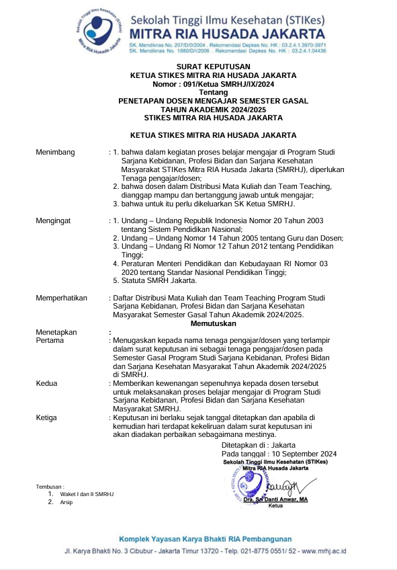

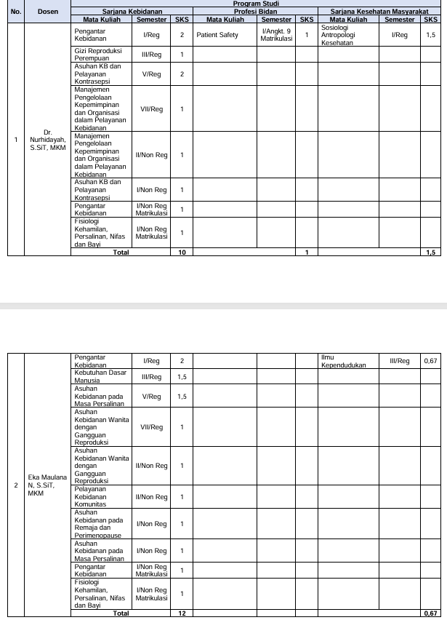

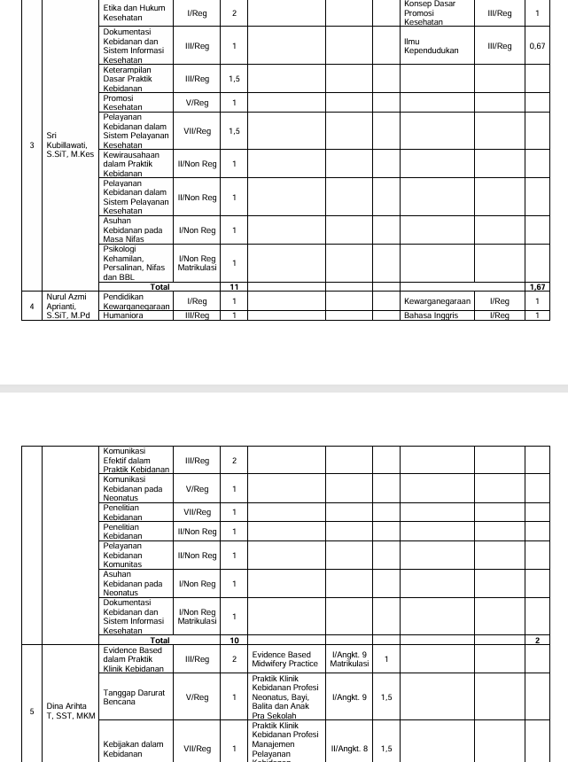

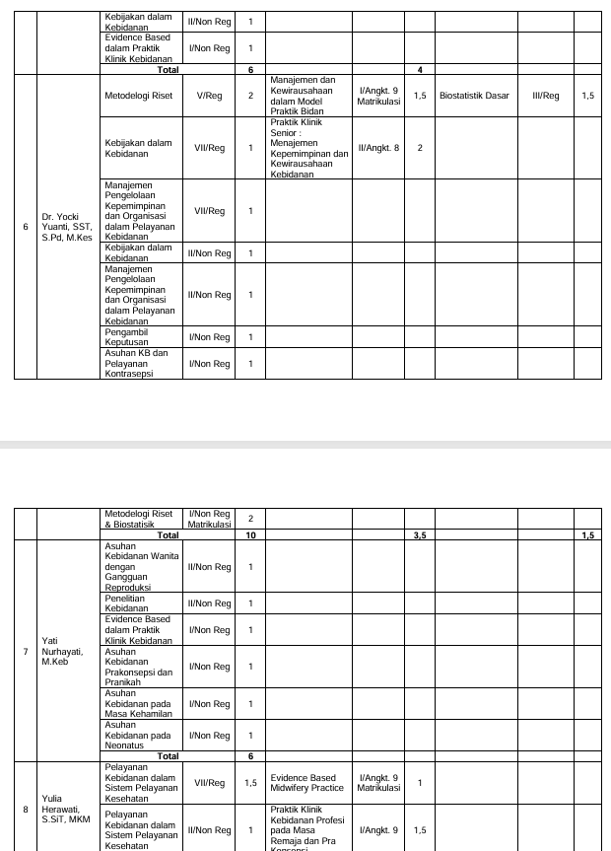

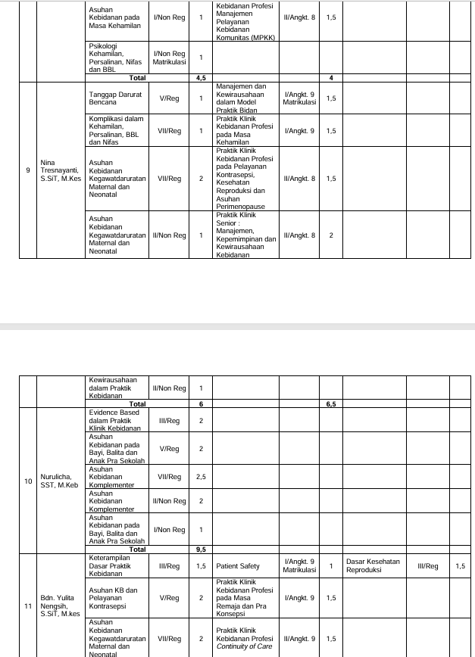

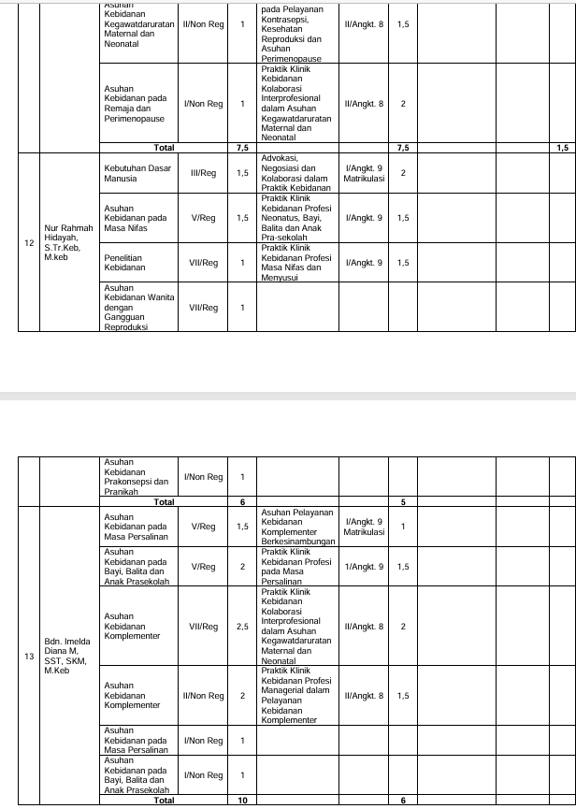

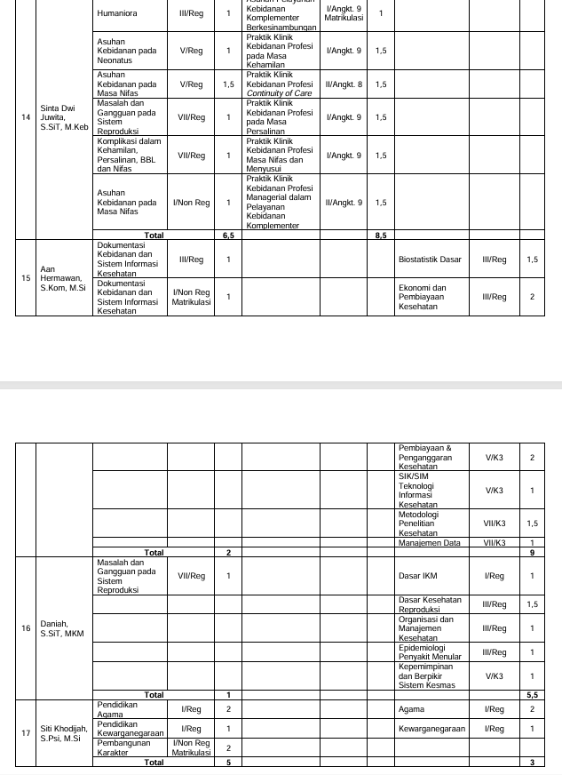

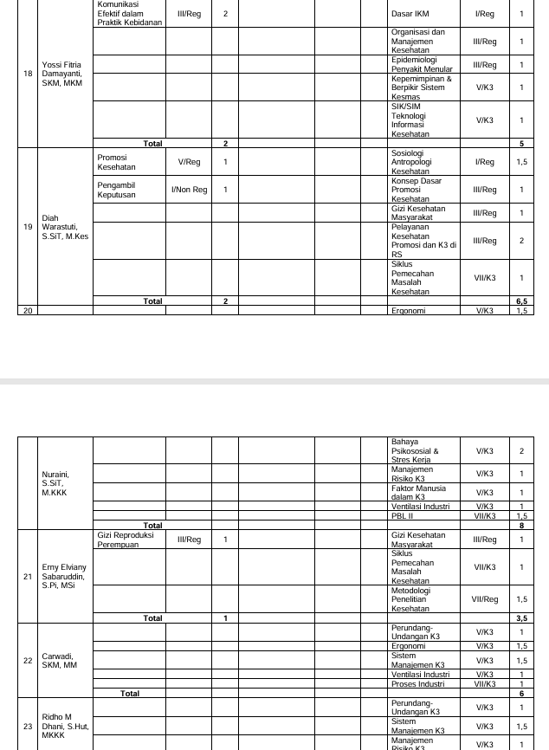

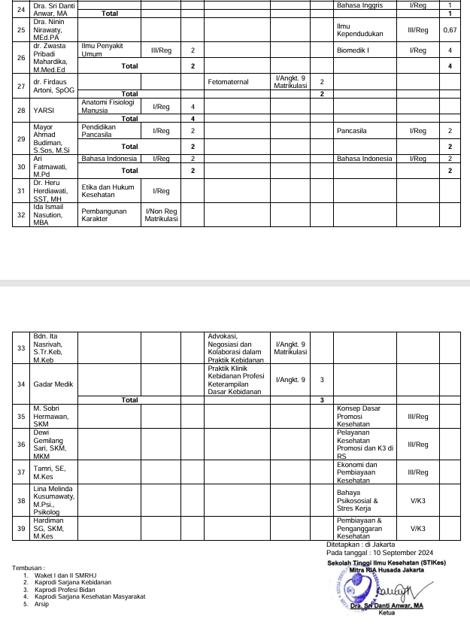

|  |  |
| --- | --- |
|  |  |

**LAPORAN NILAI MAHASISWA S1 – KEBIDANAN-20241**

|  |  |  |  |  |  |
| --- | --- | --- | --- | --- | --- |
| Mata kuliah | : | ASUHAN KEBIDANAN WANITA DENGAN GANGGUAN REPRODUKSI | Nama Kelas | : | 2 A |
| Kode Mata kuliah | : | BD63133 | SKS | : | 2 |

|  |  |  |  |  |  |  |  |  |  |  |
| --- | --- | --- | --- | --- | --- | --- | --- | --- | --- | --- |
| **No** | **NIM** | **Nama Mahasiswa** | **TUGAS INDIVIDU (25%)** | **QUIZ (10%)** | **PARTISIPAN (10%)** | **UTS (25%)** | **UAS (30%)** | **Nilai** | **Grade** | **Lulus** |
| 1 | 23503080 | PURWANTI | 80.00 | 80.00 | 75.00 | 64.00 | 65.00 | 71.00 | B | ✔ |
| 2 | 23504001 | MONIKA AUNIKE KAIROA | 80.00 | 80.00 | 80.00 | 62.00 | 65.00 | 71.00 | B | ✔ |
| 3 | 23504002 | NURLAILA | 80.00 | 80.00 | 80.00 | 65.00 | 77.00 | 75.35 | B | ✔ |
| 4 | 23504003 | RIAN NURWULAN | 80.00 | 80.00 | 80.00 | 92.50 | 80.00 | 83.13 | A- | ✔ |
| 5 | 23504004 | SITI MU’ALLIFAH | 80.00 | 80.00 | 80.00 | 62.50 | 77.00 | 74.73 | B | ✔ |
| 6 | 23504005 | ILA SAKIA | 80.00 | 80.00 | 80.00 | 65.00 | 70.00 | 73.25 | B | ✔ |
| 7 | 23504006 | RATU MUNYATUNNUFUS | 80.00 | 80.00 | 80.00 | 90.00 | 65.00 | 78.00 | B+ | ✔ |
| 8 | 23504007 | SHERLIANTY PATALLE | 80.00 | 80.00 | 80.00 | 95.00 | 78.00 | 83.15 | A- | ✔ |
| 9 | 23504008 | JUJU JUMALIYAH | 80.00 | 80.00 | 80.00 | 72.50 | 72.00 | 75.73 | B | ✔ |
| 10 | 23504009 | WINDI MUKTI NINGTYAS | 80.00 | 80.00 | 80.00 | 80.00 | 67.00 | 76.10 | B+ | ✔ |
| 11 | 23504010 | RATNARIA MESAK BAU | 80.00 | 80.00 | 80.00 | 80.00 | 60.00 | 74.00 | B | ✔ |
| 12 | 23504011 | DELVIA SEPTIANI | 80.00 | 80.00 | 80.00 | 90.00 | 75.00 | 81.00 | A- | ✔ |
| 13 | 23504012 | LADY NOVANIEGUINIE ANOGA | 80.00 | 80.00 | 80.00 | 87.50 | 75.00 | 80.38 | B+ | ✔ |
| 14 | 23504014 | MEGA WATI | 80.00 | 80.00 | 80.00 | 77.50 | 75.00 | 77.88 | B+ | ✔ |
| 15 | 23504015 | NELA ANASTHASYA OSLEKY | 80.00 | 80.00 | 80.00 | 70.00 | 75.00 | 76.00 | B+ | ✔ |
| 16 | 23504016 | ASRIANI | 80.00 | 80.00 | 80.00 | 65.00 | 75.00 | 74.75 | B | ✔ |
| 17 | 23504017 | YULAICHA | 80.00 | 80.00 | 80.00 | 77.50 | 77.00 | 78.48 | B+ | ✔ |
| 18 | 23504018 | TITA DEVI PEBRIANTI | 80.00 | 80.00 | 80.00 | 52.50 | 80.00 | 73.13 | B | ✔ |
| 19 | 23504019 | LENI AGUSLIANI | 80.00 | 80.00 | 80.00 | 72.50 | 77.00 | 77.23 | B+ | ✔ |
| 20 | 23504020 | FARIDA | 80.00 | 80.00 | 80.00 | 95.00 | 80.00 | 83.75 | A- | ✔ |
| 21 | 23504021 | NORMA JUNITA DOI | 80.00 | 80.00 | 80.00 | 66.00 | 62.00 | 71.10 | B | ✔ |
| 22 | 23504022 | SITI NUR AHYANI | 80.00 | 80.00 | 82.00 | 87.50 | 78.00 | 81.48 | A- | ✔ |
| 23 | 23504023 | FADHILAH HIDAYATY | 80.00 | 80.00 | 88.00 | 70.00 | 80.00 | 78.30 | B+ | ✔ |
| 24 | 23504024 | YUFIRA FAUZIAH ZAHRA | 0.00 |  |  |  |  | 0.00 | E |  |
| 25 | 23504025 | NAOMI FELLE | 80.00 | 80.00 | 80.00 | 62.00 | 65.00 | 71.00 | B | ✔ |
| 26 | 23504026 | YULIA HERLIYANTI | 80.00 | 80.00 | 80.00 | 82.50 | 78.00 | 80.03 | B+ | ✔ |
| 27 | 23504027 | SELVIANA BIANTONG PARA'PAK | 80.00 | 80.00 | 80.00 | 65.00 | 65.00 | 71.75 | B | ✔ |
| 28 | 23504028 | ADE NURSYAMSIAH | 80.00 | 80.00 | 80.00 | 75.00 | 81.00 | 79.05 | B+ | ✔ |
| 29 | 23504029 | LILI HADIJAH | 80.00 | 80.00 | 80.00 | 67.50 | 80.00 | 76.88 | B+ | ✔ |
| 30 | 23504030 | DILA MARDIANA | 80.00 | 80.00 | 81.00 | 90.00 | 78.00 | 82.00 | A- | ✔ |
| 31 | 23504031 | CINDI APULITA BR SITEPU | 80.00 | 80.00 | 81.00 | 95.00 | 78.00 | 83.25 | A- | ✔ |
| 32 | 23504032 | LUCIA DWI LESTIYOWATI PAREIRA | 80.00 | 80.00 | 80.00 | 49.00 | 76.00 | 71.05 | B | ✔ |

|  |
| --- |
| Tanggal Cetak : Rabu, 5 Februari 2025, 10:37:20 |
| Paraf Dosen : YATI NURHAYATI, S.ST., M.Keb E:\Prodi Profesi Bidan\Foto tanda tangan Yati.jpg EKA MAULANA NURZANNAH, S.SiT, MKM C:\Users\LAB_KEBIDANAN\Downloads\WhatsApp Image 2024-03-01 at 10.15.11 (1).jpeg |

|  |  |  |
| --- | --- | --- |
| **NILAI PERKULIAHAN MAHASISWA, PRODI** | **:** | **S1 - KEBIDANAN** |
| **PERIODE** | **:** | **20241** |

|  |  |  |  |  |  |
| --- | --- | --- | --- | --- | --- |
| Mata kuliah | : | ASUHAN KEBIDANAN WANITA DENGAN GANGGUAN REPRODUKSI | Nama Kelas | : | 2 B |
| Kode Mata kuliah | : | BD63133 | SKS | : | 2 |

|  |  |  |  |  |  |  |  |  |  |  |
| --- | --- | --- | --- | --- | --- | --- | --- | --- | --- | --- |
| **No** | **NIM** | **Nama Mahasiswa** | **TUGAS INDIVIDU (25%)** | **QUIZ (10%)** | **PARTISIPAN (10%)** | **UTS (25%)** | **UAS (30%)** | **Nilai** | **Grade** | **Lulus** |
| 1 | 23504013 | NURLAILA | 80.00 | 80.00 | 80.00 | 55.00 | 80.00 | 73.75 | B | ✔ |
| 2 | 23504033 | SITI UNAYAH | 80.00 | 80.00 | 80.00 | 90.00 | 70.00 | 79.50 | B+ | ✔ |
| 3 | 23504034 | MARGRET ERIKA NORIWARI | 80.00 | 80.00 | 80.00 | 62.00 | 65.00 | 71.00 | B | ✔ |
| 4 | 23504035 | MARGARETHA STELLA GRACIA OKOSERAY | 80.00 | 80.00 | 80.00 | 62.00 | 65.00 | 71.00 | B | ✔ |
| 5 | 23504036 | IRNA ASRI HIDAYATI | 80.00 | 80.00 | 80.00 | 65.00 | 80.00 | 76.25 | B+ | ✔ |
| 6 | 23504037 | DETI PRAHASTI | 80.00 | 80.00 | 80.00 | 90.00 | 80.00 | 82.50 | A- | ✔ |
| 7 | 23504038 | MAE IRMAWATI | 80.00 | 80.00 | 80.00 | 82.50 | 82.00 | 81.23 | A- | ✔ |
| 8 | 23504040 | SITI JAENAB | 80.00 | 80.00 | 80.00 | 45.00 | 81.00 | 71.55 | B | ✔ |
| 9 | 23504041 | SALSA AMELIA | 80.00 | 80.00 | 80.00 | 52.50 | 80.00 | 73.13 | B | ✔ |
| 10 | 23504042 | KUSMAWATI HASANAH |  |  |  |  |  |  |  |  |
| 11 | 23504043 | YURIKE ANANDITA KUSUMASTUTI | 80.00 | 80.00 | 80.00 | 87.50 | 82.00 | 82.48 | A- | ✔ |
| 12 | 23504044 | RISA NABILA | 80.00 | 80.00 | 80.00 | 87.50 | 72.00 | 79.48 | B+ | ✔ |
| 13 | 23504045 | RINI MULYASARI | 80.00 | 80.00 | 80.00 | 75.00 | 75.00 | 77.25 | B+ | ✔ |
| 14 | 23504046 | YUNI KHAERUNNISA | 80.00 | 80.00 | 80.00 | 82.50 | 75.00 | 79.13 | B+ | ✔ |
| 15 | 23504047 | ANGELA YOSINA WAISAMON | 80.00 | 80.00 | 80.00 | 62.00 | 65.00 | 71.00 | B | ✔ |
| 16 | 23504048 | DINA YAKARIMILENA | 80.00 | 80.00 | 80.00 | 62.00 | 65.00 | 71.00 | B | ✔ |
| 17 | 23504049 | ERNA ENGGELINA NASENDI | 80.00 | 80.00 | 80.00 | 58.50 | 68.00 | 71.03 | B | ✔ |
| 18 | 23504050 | SUMINAR | 80.00 | 80.00 | 80.00 | 62.50 | 77.00 | 74.73 | B | ✔ |
| 19 | 23504051 | YULIAWATI | 80.00 | 80.00 | 80.00 | 85.00 | 77.00 | 80.35 | B+ | ✔ |
| 20 | 23504052 | FATIMAH PAIMAN |  |  |  |  |  |  |  |  |
| 21 | 23504053 | ALMELINA ROS YAKARIMILENA | 80.00 | 80.00 | 80.00 | 72.50 | 66.00 | 73.93 | B | ✔ |
| 22 | 23504054 | YULIASTIA HAPIFAH | 80.00 | 80.00 | 82.00 | 72.50 | 78.00 | 77.73 | B+ | ✔ |
| 23 | 23504055 | ANA FEBRIANI | 80.00 | 80.00 | 88.00 | 82.50 | 78.00 | 80.83 | B+ | ✔ |
| 24 | 23504056 | AMALIYATUS SA'DIAH | 80.00 | 80.00 | 80.00 | 90.00 | 85.00 | 84.00 | A- | ✔ |
| 25 | 23504057 | RESTU PADILAH | 80.00 | 80.00 | 80.00 | 57.50 | 80.00 | 74.38 | B | ✔ |
| 26 | 23504058 | SUKMANAH | 80.00 | 80.00 | 80.00 | 55.00 | 80.00 | 73.75 | B | ✔ |
| 27 | 23504060 | YULI ASIH | 80.00 | 80.00 | 80.00 | 56.00 | 70.00 | 71.00 | B | ✔ |
| 28 | 23504061 | OLGA JENNI JARISETOUW | 80.00 | 80.00 | 80.00 | 62.00 | 65.00 | 71.00 | B | ✔ |
| 29 | 23504062 | IVSA MANGIWA | 80.00 | 80.00 | 80.00 | 72.50 | 65.00 | 73.63 | B | ✔ |
| Tanggal Cetak : Rabu, 5 Februari 2025, 10:37:20 | | | | | | | | | | | |
| Paraf Dosen : YATI NURHAYATI, S.ST., M.Keb E:\Prodi Profesi Bidan\Foto tanda tangan Yati.jpg EKA MAULANA NURZANNAH, S.SiT, MKM C:\Users\LAB_KEBIDANAN\Downloads\WhatsApp Image 2024-03-01 at 10.15.11 (1).jpeg | | | | | | | | | | | |

**LAPORAN PERSENTASE PRESENSI MAHASISWA S1 – KEBIDANAN-20241**

|  |  |  |  |  |  |
| --- | --- | --- | --- | --- | --- |
| Mata kuliah | : | ASUHAN KEBIDANAN WANITA DENGAN GANGGUAN REPRODUKSI | Nama Kelas | : | 2 A |
| Dosen Pengajar | : | YATI NURHAYATI |  |  |  |

|  |  |  |  |  |  |  |  |  |  |  |  |
| --- | --- | --- | --- | --- | --- | --- | --- | --- | --- | --- | --- |
| **No** | **NIM** | **Nama** | **Pertemuan** | **Alfa** | **Hadir** | | **Ijin** | **Sakit** | **Presentase** | | |
| Peserta Reguler | | | | | | | | | | | |
| 1 | 23503080 | PURWANTI | 16 |  | 16 | |  |  | 100 | | |
| 2 | 23504001 | MONIKA AUNIKE KAIROA | 16 |  | 16 | |  |  | 100 | | |
| 3 | 23504002 | NURLAILA | 16 |  | 16 | |  |  | 100 | | |
| 4 | 23504003 | RIAN NURWULAN | 16 |  | 16 | |  |  | 100 | | |
| 5 | 23504004 | SITI MU’ALLIFAH | 16 |  | 16 | |  |  | 100 | | |
| 6 | 23504005 | ILA SAKIA | 16 |  | 16 | |  |  | 100 | | |
| 7 | 23504006 | RATU MUNYATUNNUFUS | 16 |  | 16 | |  |  | 100 | | |
| 8 | 23504007 | SHERLIANTY PATALLE | 16 |  | 16 | |  |  | 100 | | |
| 9 | 23504008 | JUJU JUMALIYAH | 16 |  | 16 | |  |  | 100 | | |
| 10 | 23504009 | WINDI MUKTI NINGTYAS | 16 |  | 16 | |  |  | 100 | | |
| 11 | 23504010 | RATNARIA MESAK BAU | 16 |  | 16 | |  |  | 100 | | |
| 12 | 23504011 | DELVIA SEPTIANI | 16 |  | 16 | |  |  | 100 | | |
| 13 | 23504012 | LADY NOVANIEGUINIE ANOGA | 16 |  | 16 | |  |  | 100 | | |
| 14 | 23504014 | MEGA WATI | 16 |  | 16 | |  |  | 100 | | |
| 15 | 23504015 | NELA ANASTHASYA OSLEKY | 16 |  | 16 | |  |  | 100 | | |
| 16 | 23504016 | ASRIANI | 16 |  | 16 | |  |  | 100 | | |
| 17 | 23504017 | YULAICHA | 16 |  | 16 | |  |  | 100 | | |
| 18 | 23504018 | TITA DEVI PEBRIANTI | 16 |  | 16 | |  |  | 100 | | |
| 19 | 23504019 | LENI AGUSLIANI | 16 |  | 16 | |  |  | 100 | | |
| 20 | 23504020 | FARIDA | 16 |  | 16 | |  |  | 100 | | |
| 21 | 23504021 | NORMA JUNITA DOI | 16 |  | 16 | |  |  | 100 | | |
| 22 | 23504022 | SITI NUR AHYANI | 16 |  | 16 | |  |  | 100 | | |
| 23 | 23504023 | FADHILAH HIDAYATY | 16 |  | 16 | |  |  | 100 | | |
| 24 | 23504024 | YUFIRA FAUZIAH ZAHRA | 16 |  | 16 | |  |  | 100 | | |
| 25 | 23504025 | NAOMI FELLE | 16 |  | 16 | |  |  | 100 | | |
| 26 | 23504026 | YULIA HERLIYANTI | 16 |  | 16 | |  |  | 100 | | |
| 27 | 23504027 | SELVIANA BIANTONG PARA'PAK | 16 |  | 16 | |  |  | 100 | | |
| 28 | 23504028 | ADE NURSYAMSIAH | 16 |  | 16 | |  |  | 100 | | |
| 29 | 23504029 | LILI HADIJAH | 16 |  | 16 | |  |  | 100 | | |
| 30 | 23504030 | DILA MARDIANA | 16 |  | 16 | |  |  | 100 | | |
| 31 | 23504031 | CINDI APULITA BR SITEPU | 16 |  | 16 | |  |  | 100 | | |
| 32 | 23504032 | LUCIA DWI LESTIYOWATI PAREIRA | 16 |  | 16 | |  |  | 100 | | |
| Mata kuliah | | | : | ASUHAN KEBIDANAN WANITA DENGAN GANGGUAN REPRODUKSI | | | Nama Kelas | | | : | 2 B |

|  |  |  |  |  |  |  |  |  |
| --- | --- | --- | --- | --- | --- | --- | --- | --- |
| **No** | **NIM** | **Nama** | **Pertemuan** | **Alfa** | **Hadir** | **Ijin** | **Sakit** | **Presentase** |
| 1 | 23504013 | NURLAILA | 16 |  | 9 |  |  | 56.25 |
| 2 | 23504033 | SITI UNAYAH | 16 |  | 9 |  |  | 56.25 |
| 3 | 23504034 | MARGRET ERIKA NORIWARI | 16 |  | 9 |  |  | 56.25 |
| 4 | 23504035 | MARGARETHA STELLA GRACIA OKOSERAY | 16 |  | 9 |  |  | 56.25 |
| 5 | 23504036 | IRNA ASRI HIDAYATI | 16 |  | 9 |  |  | 56.25 |
| 6 | 23504037 | DETI PRAHASTI | 16 |  | 9 |  |  | 56.25 |
| 7 | 23504038 | MAE IRMAWATI | 16 |  | 9 |  |  | 56.25 |
| 8 | 23504040 | SITI JAENAB | 16 |  | 9 |  |  | 56.25 |
| 9 | 23504041 | SALSA AMELIA | 16 |  | 9 |  |  | 56.25 |
| 10 | 23504042 | KUSMAWATI HASANAH | 16 |  | 9 |  |  | 56.25 |
| 11 | 23504043 | YURIKE ANANDITA KUSUMASTUTI | 16 |  | 9 |  |  | 56.25 |
| 12 | 23504044 | RISA NABILA | 16 |  | 9 |  |  | 56.25 |
| 13 | 23504045 | RINI MULYASARI | 16 |  | 9 |  |  | 56.25 |
| 14 | 23504046 | YUNI KHAERUNNISA | 16 |  | 9 |  |  | 56.25 |
| 15 | 23504047 | ANGELA YOSINA WAISAMON | 16 |  | 9 |  |  | 56.25 |
| 16 | 23504048 | DINA YAKARIMILENA | 16 |  | 9 |  |  | 56.25 |
| 17 | 23504049 | ERNA ENGGELINA NASENDI | 16 |  | 9 |  |  | 56.25 |
| 18 | 23504050 | SUMINAR | 16 |  | 9 |  |  | 56.25 |
| 19 | 23504051 | YULIAWATI | 16 |  | 9 |  |  | 56.25 |
| 20 | 23504052 | FATIMAH PAIMAN | 16 |  | 9 |  |  | 56.25 |
| 21 | 23504053 | ALMELINA ROS YAKARIMILENA | 16 |  | 9 |  |  | 56.25 |
| 22 | 23504054 | YULIASTIA HAPIFAH | 16 |  | 9 |  |  | 56.25 |
| 23 | 23504055 | ANA FEBRIANI | 16 |  | 9 |  |  | 56.25 |
| 24 | 23504056 | AMALIYATUS SA'DIAH | 16 |  | 9 |  |  | 56.25 |
| 25 | 23504057 | RESTU PADILAH | 16 |  | 9 |  |  | 56.25 |
| 26 | 23504058 | SUKMANAH | 16 |  | 9 |  |  | 56.25 |
| 27 | 23504060 | YULI ASIH | 16 |  | 9 |  |  | 56.25 |
| 28 | 23504061 | OLGA JENNI JARISETOUW | 16 |  | 9 |  |  | 56.25 |
| 29 | 23504062 | IVSA MANGIWA | 16 |  | 9 |  |  | 56.25 |

Jakarta, 05 Februari 2025  
Ketua Prodi S1 - Kebidanan  
  
Dr. NURHIDAYAH, S.SiT, MKM  
NIP. 0323057501

