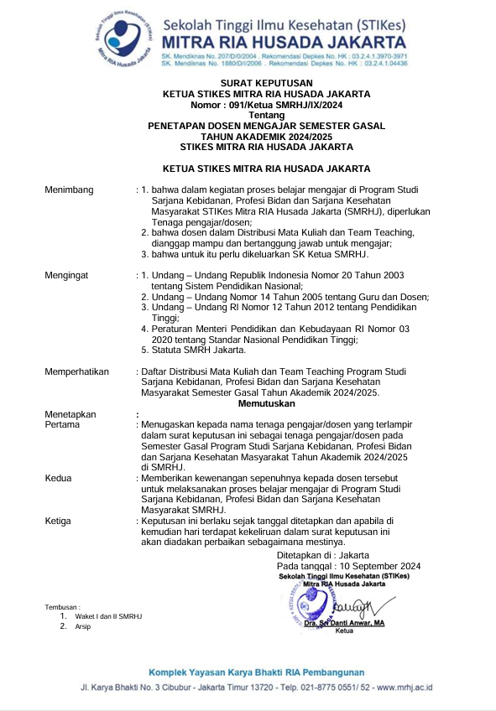

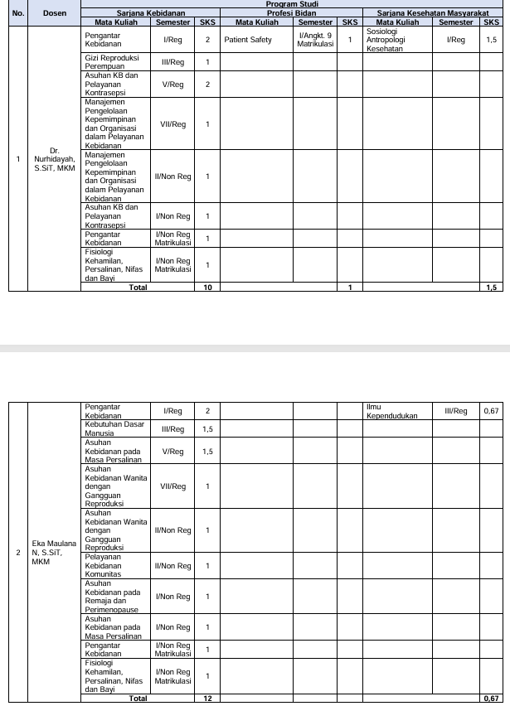

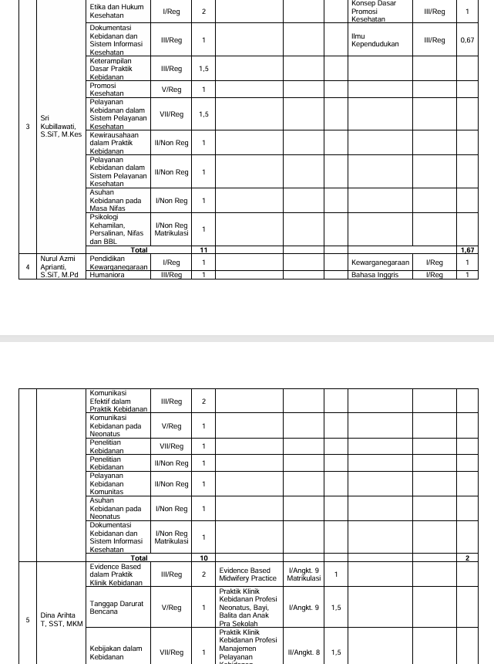

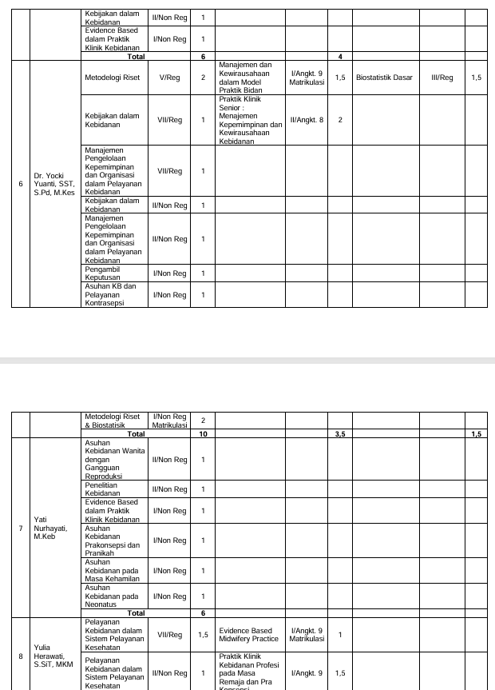

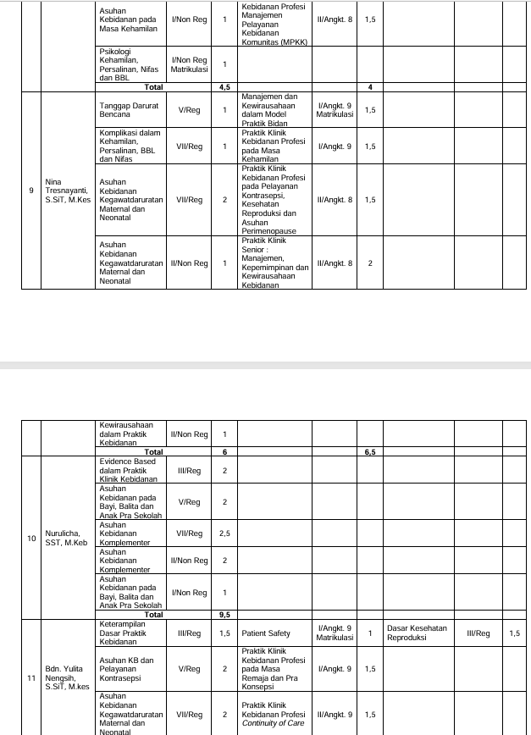

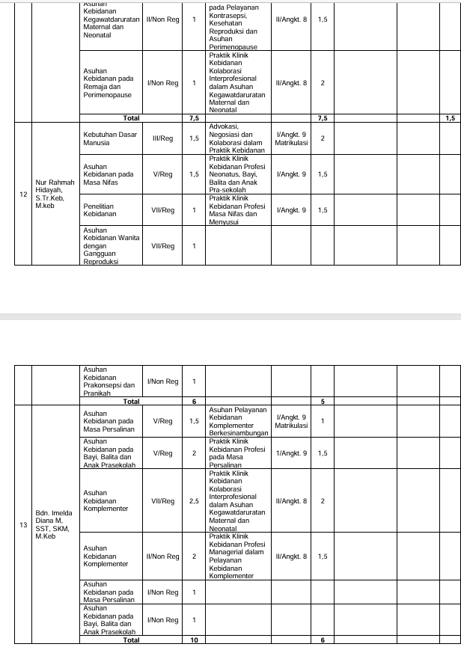

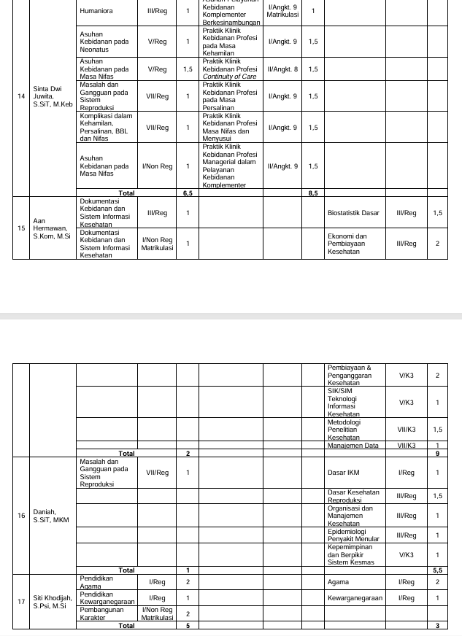

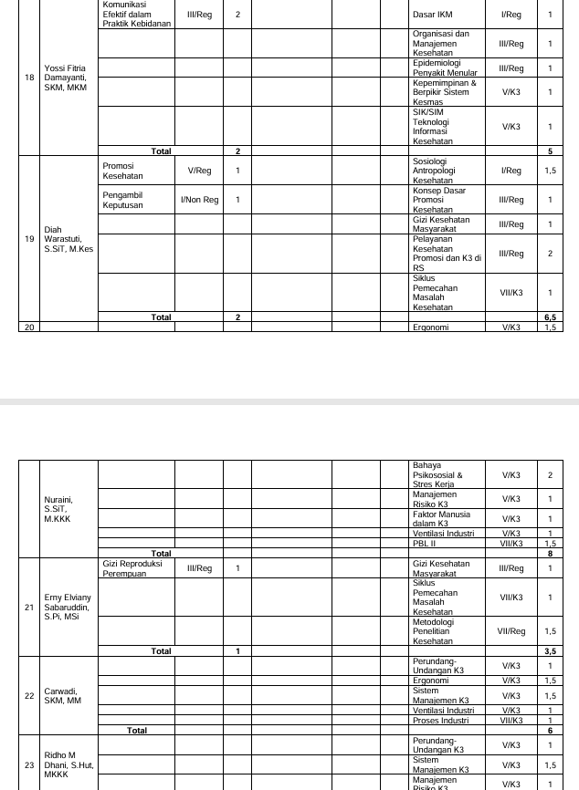

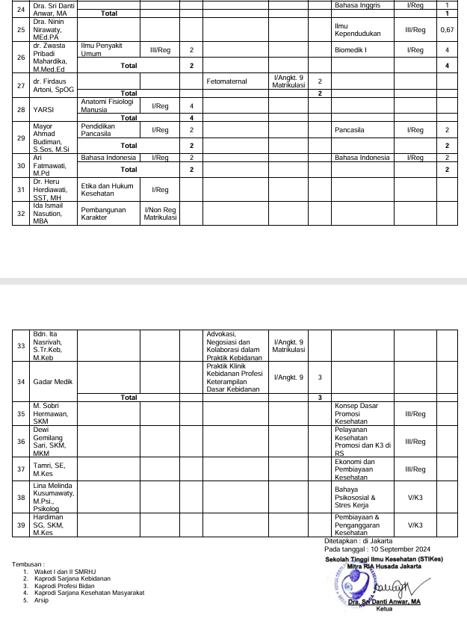

|  |  |  |
| --- | --- | --- |
|  |  |  |

**NILAI PERKULIAHAN MAHASISWA**

|  |  |  |
| --- | --- | --- |
| **PRODI** | **:** | **S1 - KEBIDANAN** |
| **PERIODE** | **:** | **20241** |

|  |  |  |  |  |  |
| --- | --- | --- | --- | --- | --- |
| Mata kuliah | : | ASUHAN KEBIDANAN WANITA DENGAN GANGGUAN REPRODUKSI | Nama Kelas | : | REG 7 |
| Kode Mata kuliah | : | BD63133. | SKS | : | 2 |

|  |  |  |  |  |  |  |  |  |  |  |  |  |
| --- | --- | --- | --- | --- | --- | --- | --- | --- | --- | --- | --- | --- |
| **No** | **NIM** | **Nama Mahasiswa** | **TUGAS INDIVIDU (25%)** | **QUIZ (10%)** | **PARTISIPAN (10%)** | **UTS (25%)** | **UAS (30%)** | **Nilai** | **Grade** | **Lulus** | **Sunting KRS?** | **Info** |
| 1 | 21404001 | MITHAHUL MAULA | 85.00 | 80.00 | 80.00 | 55.00 | 95.00 | 79.50 | B+ | ✔ |  |  |
| 2 | 21404002 | IMELDA SALIM | 80.00 | 90.00 | 85.00 | 93.00 | 100.00 | 90.75 | A | ✔ |  |  |
| 3 | 21404003 | SHIFA SILVIANI | 85.00 | 70.00 | 85.00 | 89.00 | 100.00 | 89.00 | A | ✔ |  |  |
| 4 | 21404005 | FARA SABRINA OKTAVINATRY | 85.00 | 80.00 | 80.00 | 90.00 | 95.00 | 88.25 | A | ✔ |  |  |
| 5 | 21404007 | DELLA AMELIA PUTRI | 80.00 | 80.00 | 80.00 | 80.00 | 100.00 | 86.00 | A | ✔ |  |  |
| 6 | 21404008 | IIS SITI AISAH | 85.00 | 80.00 | 90.00 | 77.00 | 90.00 | 84.50 | A- | ✔ |  |  |
| 7 | 21404009 | ANANDA RIZKI SARI | 80.00 | 80.00 | 80.00 | 93.00 | 100.00 | 89.25 | A | ✔ |  |  |
| 8 | 21404010 | SITI PATIMAH | 85.00 | 40.00 | 80.00 | 59.00 | 90.00 | 75.00 | B | ✔ |  |  |
| Tanggal Cetak : Rabu, 5 Februari 2025, 09:06:18 | | | | | | | | | | | | | |
| Paraf Dosen : YATI NURHAYATI, S.ST., M.Keb E:\Prodi Profesi Bidan\Foto tanda tangan Yati.jpg EKA MAULANA NURZANNAH, S.SiT, MKM C:\Users\LAB_KEBIDANAN\Downloads\WhatsApp Image 2024-03-01 at 10.15.11 (1).jpeg Nur Rahmah Hidayah, STR.Keb., M.Keb C:\Users\LAB_KEBIDANAN\Downloads\WhatsApp Image 2024-01-16 at 13.15.11.jpeg | | | | | | | | | | | | | |

**ISI PRESENSI DOSEN S1 – KEBIDANAN- 20241**

|  |  |  |  |  |  |
| --- | --- | --- | --- | --- | --- |
| Mata kuliah | : | BD63133. - ASUHAN KEBIDANAN WANITA DENGAN GANGGUAN REPRODUKSI | Nama Kelas | : | REG 7 |

|  |  |  |  |  |  |  |  |  |  |  |  |  |  |  |  |  |  |  |
| --- | --- | --- | --- | --- | --- | --- | --- | --- | --- | --- | --- | --- | --- | --- | --- | --- | --- | --- |
| **No** | **NIP** | **NAMA** | **TATAP MUKA** | | | | | | | | | | | | | | | |
| **17 Sep 2024** | **24 Sep 2024** | **1 Okt 2024** | **8 Okt 2024** | **15 Okt 2024** | **22 Okt 2024** | **29 Okt 2024** | **6 Nov 2024** | **12 Nov 2024** | **19 Nov 2024** | **26 Nov 2024** | **3 Des 2024** | **10 Des 2024** | **17 Des 2024** | **24 Des 2024** | **6 Jan 2025** |
| 1 | 190223466 | YATI NURHAYATI | E:\Prodi Profesi Bidan\Foto tanda tangan Yati.jpg |  |  |  |  |  |  | E:\Prodi Profesi Bidan\Foto tanda tangan Yati.jpg |  |  |  |  |  |  |  |  |
| 2 | 0314128301 | EKA MAULANA NURZANNAH, S.SiT, MKM |  |  |  |  |  |  |  |  | C:\Users\LAB_KEBIDANAN\Downloads\WhatsApp Image 2024-03-01 at 10.15.11 (1).jpeg | C:\Users\LAB_KEBIDANAN\Downloads\WhatsApp Image 2024-03-01 at 10.15.11 (1).jpeg | C:\Users\LAB_KEBIDANAN\Downloads\WhatsApp Image 2024-03-01 at 10.15.11 (1).jpeg | C:\Users\LAB_KEBIDANAN\Downloads\WhatsApp Image 2024-03-01 at 10.15.11 (1).jpeg | C:\Users\LAB_KEBIDANAN\Downloads\WhatsApp Image 2024-03-01 at 10.15.11 (1).jpeg | C:\Users\LAB_KEBIDANAN\Downloads\WhatsApp Image 2024-03-01 at 10.15.11 (1).jpeg | C:\Users\LAB_KEBIDANAN\Downloads\WhatsApp Image 2024-03-01 at 10.15.11 (1).jpeg |  |
| 3 | 191223466 | Nur Rahmah Hidayah, STR.Keb., M.Keb | C:\Users\LAB_KEBIDANAN\Downloads\WhatsApp Image 2024-01-16 at 13.15.11.jpeg | C:\Users\LAB_KEBIDANAN\Downloads\WhatsApp Image 2024-01-16 at 13.15.11.jpeg | C:\Users\LAB_KEBIDANAN\Downloads\WhatsApp Image 2024-01-16 at 13.15.11.jpeg | C:\Users\LAB_KEBIDANAN\Downloads\WhatsApp Image 2024-01-16 at 13.15.11.jpeg | C:\Users\LAB_KEBIDANAN\Downloads\WhatsApp Image 2024-01-16 at 13.15.11.jpeg | C:\Users\LAB_KEBIDANAN\Downloads\WhatsApp Image 2024-01-16 at 13.15.11.jpeg | C:\Users\LAB_KEBIDANAN\Downloads\WhatsApp Image 2024-01-16 at 13.15.11.jpeg |  |  |  |  |  |  |  |  | E:\Prodi Profesi Bidan\Foto tanda tangan Yati.jpg |

**LAPORAN PERSENTASE PRESENSI MAHASISWA S1 – KEBIDANAN 20241**

|  |  |  |  |  |  |
| --- | --- | --- | --- | --- | --- |
| Mata kuliah | : | ASUHAN KEBIDANAN WANITA DENGAN GANGGUAN REPRODUKSI | Nama Kelas | : | REG 7 |
| Dosen Pengajar | : | YATI NURHAYATI |  |  |  |

|  |  |  |  |  |  |  |  |  |
| --- | --- | --- | --- | --- | --- | --- | --- | --- |
| **No** | **NIM** | **Nama** | **Pertemuan** | **Alfa** | **Hadir** | **Ijin** | **Sakit** | **Presentase** |
| Peserta Reguler | | | | | | | | |
| 1 | 21404001 | MITHAHUL MAULA | 16 |  | 14 |  |  | 87.5 |
| 2 | 21404002 | IMELDA SALIM | 16 |  | 14 |  |  | 87.5 |
| 3 | 21404003 | SHIFA SILVIANI | 16 |  | 14 |  |  | 87.5 |
| 4 | 21404005 | FARA SABRINA OKTAVINATRY | 16 |  | 14 |  |  | 87.5 |
| 5 | 21404007 | DELLA AMELIA PUTRI | 16 |  | 14 |  |  | 87.5 |
| 6 | 21404008 | IIS SITI AISAH | 16 |  | 14 |  |  | 87.5 |
| 7 | 21404009 | ANANDA RIZKI SARI | 16 |  | 14 |  |  | 87.5 |
| 8 | 21404010 | SITI PATIMAH | 16 |  | 14 |  |  | 87.5 |

Jakarta, 05 Februari 2025  
Ketua Prodi S1 - Kebidanan  
  
Dr. NURHIDAYAH, S.SiT, MKM  
NIP. 0323057501

